|  |  |
| --- | --- |
| A picture of a winding road and trees  Wedding Project Management  Meticulous Planning for a Perfect Day: Tony and Peggy Sue's Wedding Project | Abstract  This project aims to meticulously plan and execute the wedding of Tony and Peggy Sue within a 180-day timeframe, starting from January 1, 2022, and concluding on June 30, 2022. Using MS Project software, the project is structured into 11 groups, each responsible for different aspects of the wedding planning process. The tasks include date selection, budget management, venue booking, guest invitations, procurement of wedding essentials, entertainment arrangements, food and beverage management, photography and videography bookings, transportation logistics, reception management, and honeymoon planning. With 180 tasks and milestones set for each summary task, the project ensures a seamless and efficient workflow, culminating in a successfully managed wedding event. The inclusion of critical path analysis and detailed task scheduling aims to avoid delays and ensure timely completion of all activities.  Khalid Hasan Seum |

Table of Contents

**1. Introduction----------------------------------------------------------------------------------------------------------------------------------------page 1**

**2. Project Structure---------------------------------------------------------------------------------------------------------------------------------page 10**

**3. Detailed Task Breakdown-----------------------------------------------------------------------------------------------------------------------page 15**

**4. Resource Allocation-------------------------------------------------------------------------------------------------------------------------------page 20**

**5. Project Scheduling--------------------------------------------------------------------------------------------------------------------------------page 25**

**6. Network Diagram---------------------------------------------------------------------------------------------------------------------------------page 28**

**7. Conclusion-------------------------------------------------------------------------------------------------------------------------------------------page 29**

**8. Appendices-----------------------------------------------------------------------------------------------------------------------------------------page 33**

**Objective:**

Create a wedding planner so that the wedding task can be started by January 1, 2022, and successfully finished by 30 June which is a total 180 days time frame.

**List of Assumptions:**

|  |
| --- |
| 1. Date Selection and Budget Management Group(Group 1) |
| 1. Select Date |
| 1. Search for a perfect day of wedding |
| 1. Selecting date |
| 1. Getting approval for the selected date |
| 1. Date selected |
| 1. Make Budget |
| 1. Discuss about the budget |
| 1. Plan a budget |
| 1. Getting approval for budget |
| 1. Budget made |
| 1. Church and Reception booking Management Group (Group 2) |
| 1. Book Church |
| 1. Selecting Church |
| 1. Checking time availability |
| 1. Apply for booking |
| 1. Church booked |
| 1. Book Reception |
| 1. Selecting the reception place |
| 1. Checking the time availability |
| 1. Giving Payment |
| 1. Reception booked |
| 1. Guest Invitation Management Group (Group 3) |
| 1. Invite Guest |
| 1. Inviting relatives |
| 1. Getting relatives' email and phone numbers. |
| 1. Inviting friends |
| 1. Getting friend's email and phone numbers. |
| 1. Inviting neighbors |
| 1. Getting neighbor's email and phone numbers. |
| 1. Making a list of total guests with their details |
| 1. Guest Invited |
| 1. Wedding Essentials Buying Group (Group 4) |
| 1. Buy Wedding ring |
| 1. Searching for a jewellery shop |
| 1. Checking the review and rating of shops |
| 1. Selecting jewellery shop |
| 1. Selecting jewellery type |
| 1. Selecting diamond type |
| 1. Selecting ring size |
| 1. Giving Payment |
| 1. Wedding ring buying completed |
| 1. Buy Wedding outfit |
| 1. Searching for a wedding dress shop |
| 1. Researching about the shop's dress quality |
| 1. Checking the review and rating of the shop |
| 1. Selecting the dress shop |
| 1. Choosing dress for bride |
| 1. Choosing dress for groom |
| 1. Giving Payment |
| 1. Wedding outfit buying completed |
| 1. Order flowers for wedding |
| 1. Searching for flower shop |
| 1. Researching about the florists |
| 1. Selecting flower shop |
| 1. Choosing flowers fo the decorations |
| 1. Selecting the colourful flowers with great smell |
| 1. Giving Payment |
| 1. Flowers for weeding order done |
| 1. Order wedding Cake |
| 1. Search for a local weeding cake maker |
| 1. Checking about the review and ratings |
| 1. Selecting Cake maker |
| 1. Chossing the design of the cake |
| 1. Giving payment |
| 1. Wedding cake order completed |
| 1. Book a parlour |
| 1. Searching and researching for a local parlour |
| 1. Checking the facility of the parlours |
| 1. Checking the available times of the parlours |
| 1. Selecting the parlour |
| 1. Selecting time and date |
| 1. Giving Payment |
| 1. Parlour is booked |
| 1. Entertainment Management Group (Group 5) |
| 1. Book DJ |
| 1. Searching for DJ |
| 1. Reseaching about the reputation of DJ |
| 1. Checking the review and rating |
| 1. Checking the avaliablity |
| 1. Discussing about the Payment |
| 1. Giving Payment |
| 1. DJ is booked |
| 1. Book Musician |
| 1. Searching and collect data for a popular band |
| 1. Researching about the music band |
| 1. Checking the charge for concert |
| 1. Select musician |
| 1. Checking the avaliablity |
| 1. Discussing about the Payment |
| 1. Giving Payment |
| 1. Musician is booked |
| 1. Dance Rehearsal |
| 1. Selecting dance member from family member. |
| 1. Selecting the time |
| 1. Choosing song |
| 1. Taking rehearsal |
| 1. Dance reheasal completed |
| 1. Food Management Group (Group 6) |
| 1. Choose the Food Menu |
| 1. Collecting all the food menu |
| 1. Selecting special wedding menu |
| 1. Checking the availablity |
| 1. Getting the approval |
| 1. Giving Payment |
| 1. Food menu is choosen |
| 1. Book Bartender |
| 1. Searching for the bartenders |
| 1. Checking the experience of bartenders |
| 1. Checking the reviews |
| 1. Selecting bartender |
| 1. Giving Payment |
| 1. Bartender Booked |
| 1. Camera and Videography Management Group (Group 7) |
| 1. Book Photographer |
| 1. Searching the local photographer |
| 1. Researching about their photography skills and quality |
| 1. Checking about their review and ratings |
| 1. Check the availablity of the photogrphers |
| 1. Selecting the photographer |
| 1. Fixing the time |
| 1. Giving Payment |
| 1. Photographer booked |
| 1. Book Cinematographer |
| 1. Searching the Cinematographer |
| 1. Researching about their Cinematography skills and quality |
| 1. Checking about their review and ratings |
| 1. Check the availablity of the Cinematographers |
| 1. Selecting the Cinematographer |
| 1. Discussing about the wedding requirments |
| 1. Fixing the time |
| 1. Giving Payment |
| 1. Cinematographers booked |
| 1. Transport Management Group (Group 8) |
| 1. Book Transport |
| 1. Searching for transport agency |
| 1. Compare the price of the transport agencies |
| 1. Checking about their review and ratings |
| 1. Selecting agency |
| 1. Choosing wedding cars 2. Discuss about payment |
| 1. Giving Payment |
| 1. Transport Booked |
| 1. Reception Management Group (Group 9) |
| 1. Give Responsibility and Dress selection |
| 1. Telling Tony sister's to take the bridesmaid responsibility. |
| 1. Giving responsibility to Maria and Teresa to be flower girls |
| 1. Giving responsibility to Nicky to be the ring bearer |
| 1. Telling Peggy Sue sister's to take the bridesmaid responsibility. |
| 1. Selecting dress for the reception |
| 1. Responsibility given and dress selection done |
| 1. Rehearsal for Given Responsiblity |
| 1. Giving trial as a bridesmaid |
| 1. Giving trial as a ring bearer |
| 1. Giving trial as a flower girls |
| 1. Rehearsaling for giving speech |
| 1. Rehearsal done |
| 1. Honeymoon Management Group (Group 10) |
| 1. Book Ticket |
| 1. Discussing about the countries for the honeymoon |
| 1. Selecting Italy for honeymoon |
| 1. Calling Francine (the travel agent) |
| 1. Select the date of travel |
| 1. Giving Payment |
| 1. Ticket booked |
| 1. Marriage Day Management Group (Group 11) |
| 1. Wedding day checklist check |
| 1. Taking final confirmation from all the vendors and all the groups |
| 1. Ensuring all the setup is set properly |
| 1. Ensuring the security |
| 1. Giving seat plan to the guests |
| 1. Ensuring the photographer and Cinematographer is present on time |
| 1. Wedding day checklist check done |
| 1. Wedding day Convention |
| 1. Giving Speech |
| 1. Performing all the responsibility |
| 1. Receiving all the envelops and gifts |
| 1. Getting married |
| 1. Dancing with music |
| 1. Wedding day Convention done |

By using MS Project software, I created a work breakdown structure for the Wedding Planner project. The project has a total of 180 days and the project must start on 1 January 2022 and finish by 30 June 2022.

So, First of all, I create some groups for the different tasks. For specific different tasks, the project has different groups. I created a total of 11 groups for better project management for better management of the project. In every group, there are tasks for the wedding. In addition, in this project, there are a total of 180 tasks with summary tasks and milestones. I created milestones for every summary task so that, each task can be done on time and perfectly. Besides, It also increases better understandability. I’m attaching the screenshot of the ms project below.

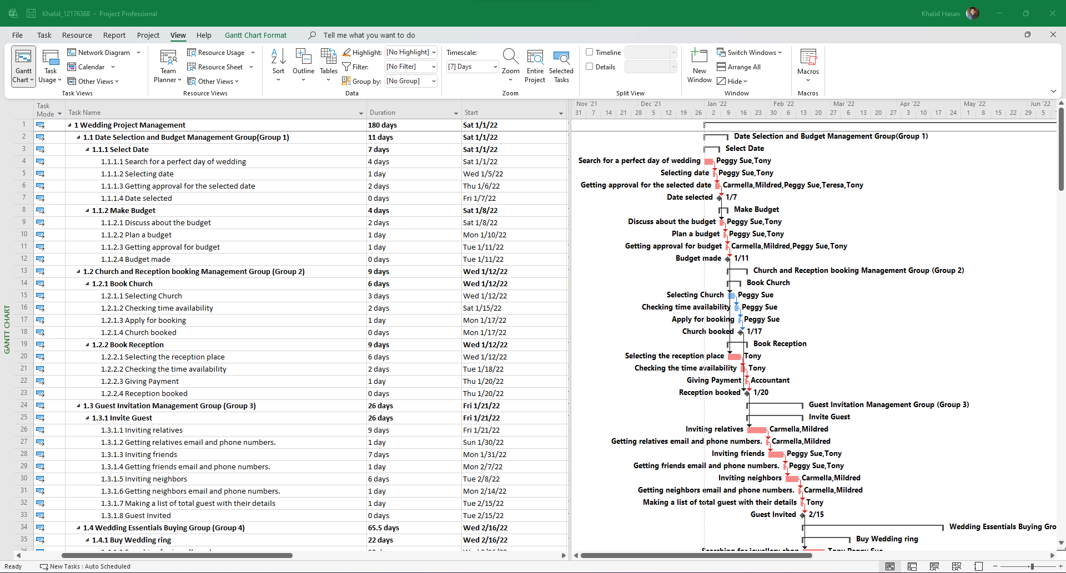

Pic 1: WBS structure for the Wedding Project.

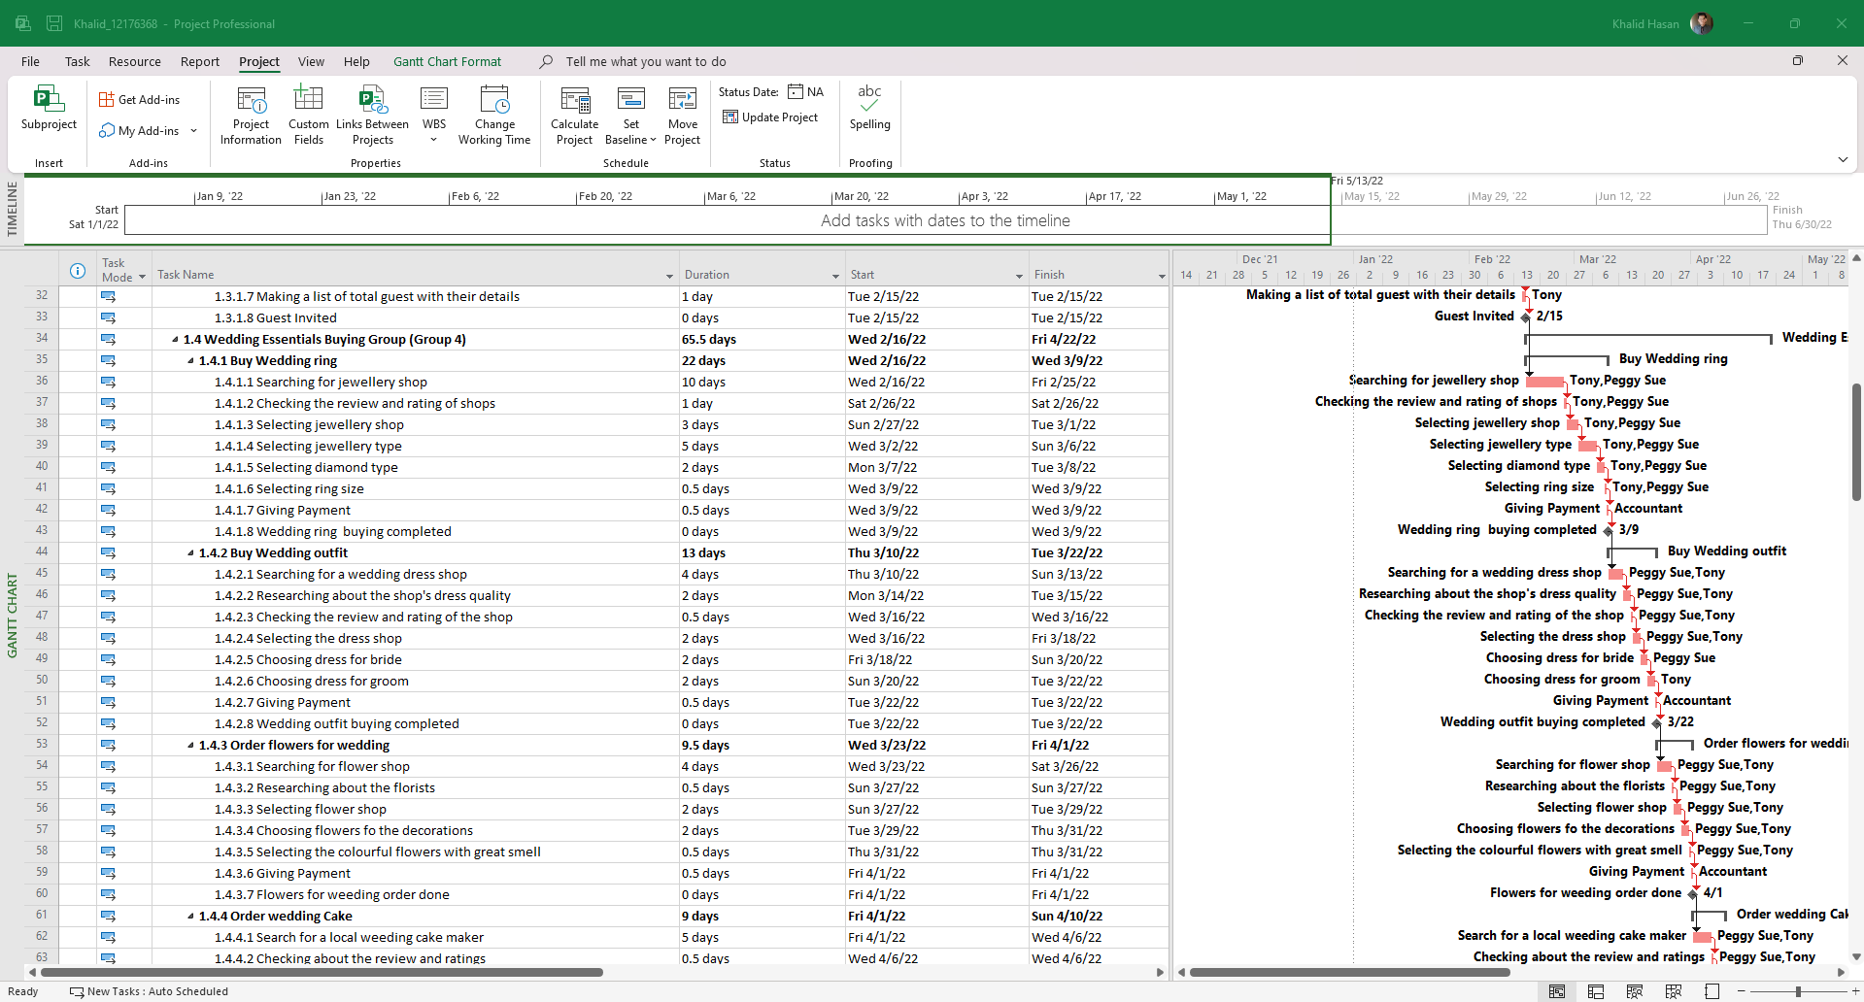

Pic 2: WBS structure for the Wedding Project.

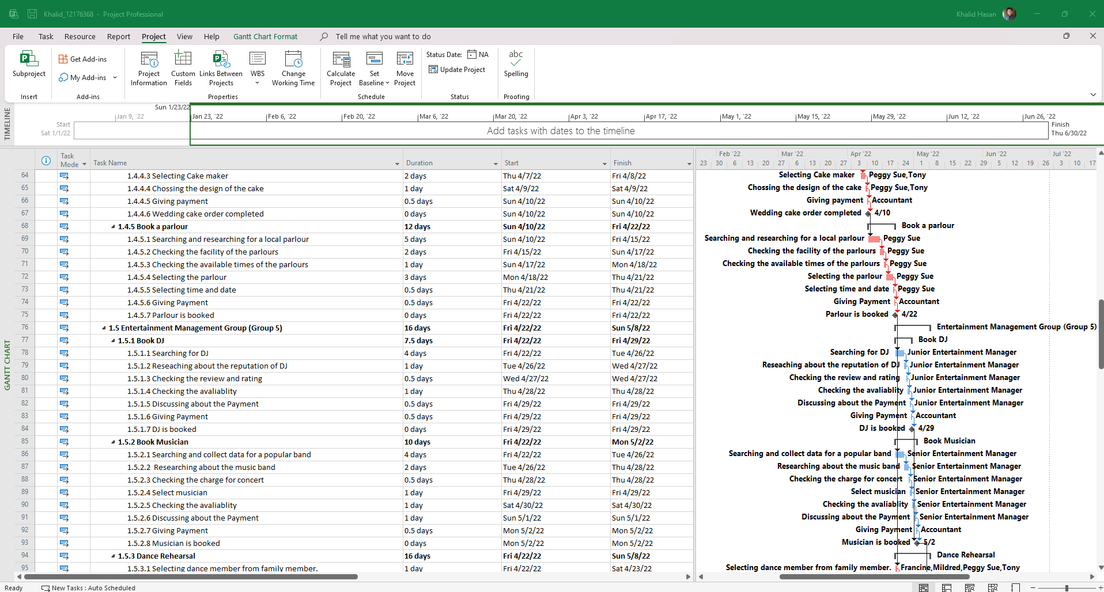

Pic 3: WBS structure for the Wedding Project.

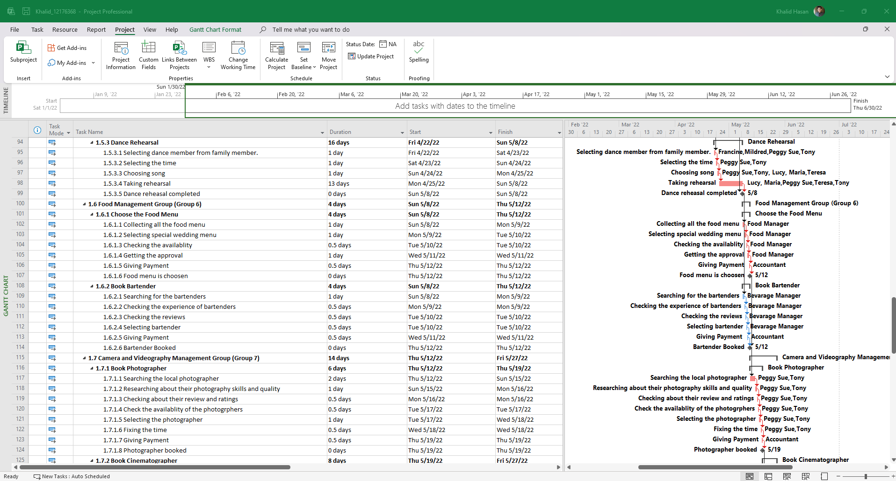

Pic 4: WBS structure for the Wedding Project.

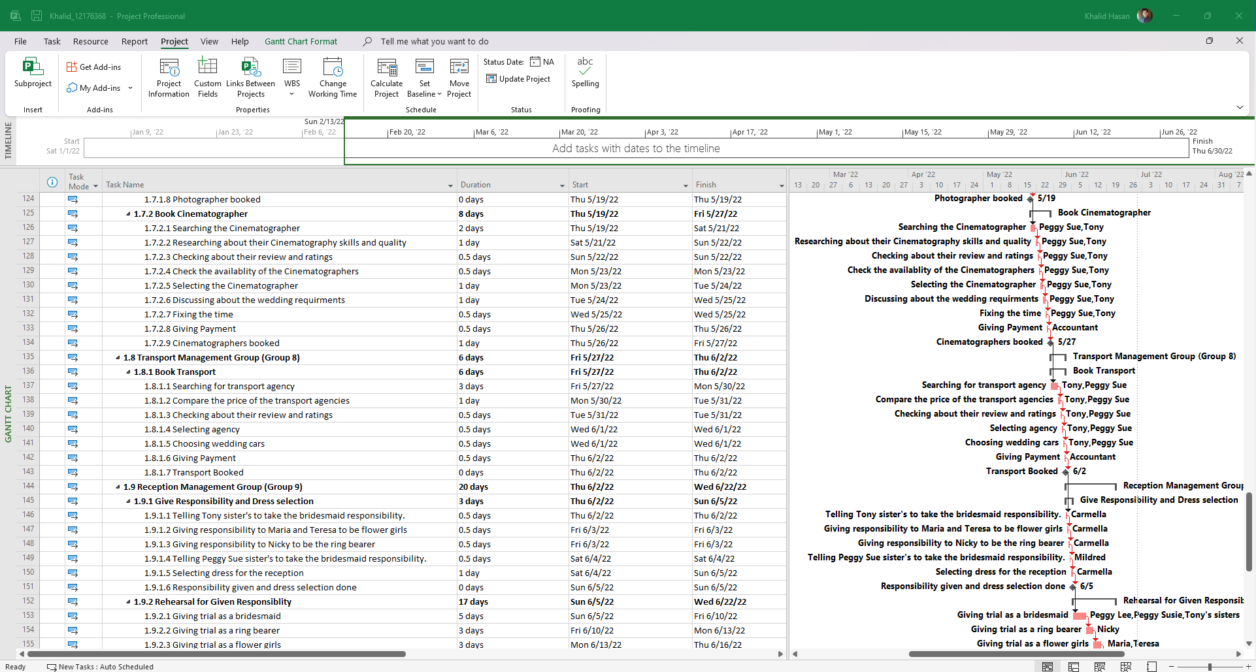

Pic 5: WBS structure for the Wedding Project.

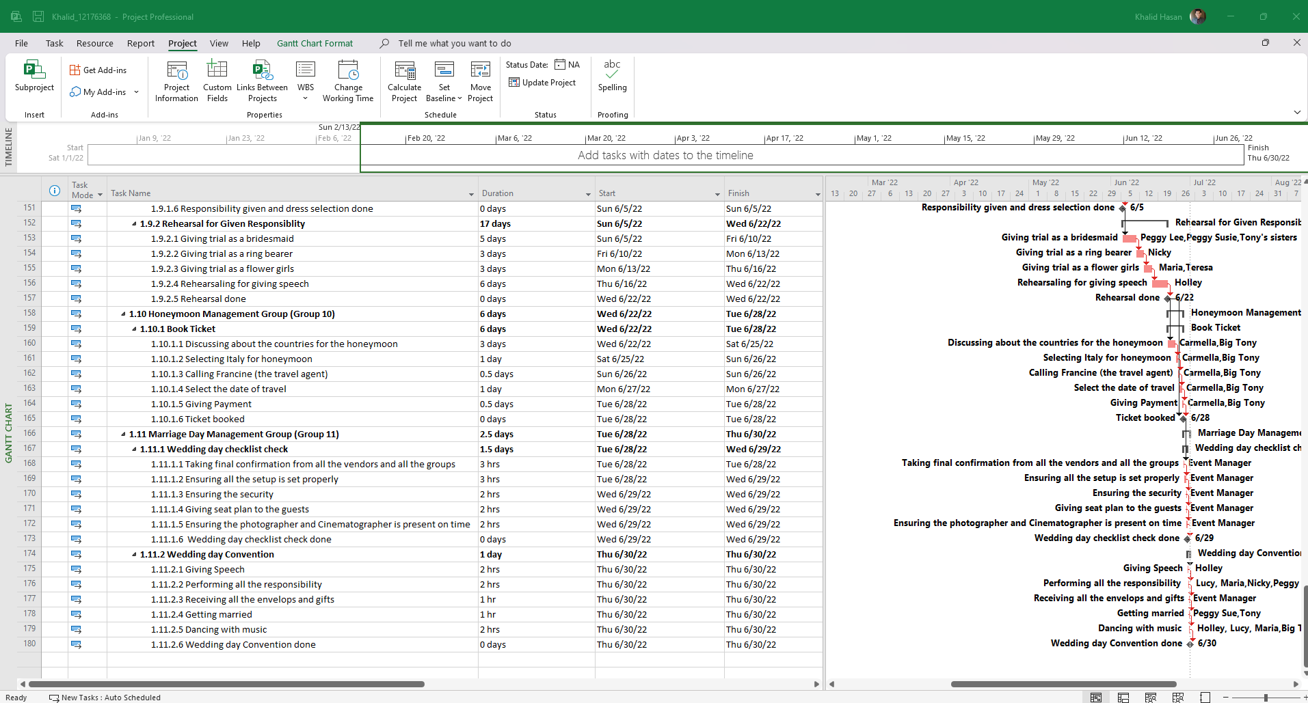

Pic 6: WBS structure for the Wedding Project.

The wedding project is based on Tony and Peggy Sue’s marriage. Their wedding task beginning date is 01 January 2022 and the closing time of their project is 30 June 2022. The time frame is 180 days. There is no break for Saturday and Sunday for the wedding project as, the wedding is one of the busiest projects and if it gets stopped for 2 days in a week, then the project will take more time to complete. But, On 13 May 2022, all the people who were involved in the wedding will take a break as mid-wedding break for their refreshments. The final day 30 June 2022, is the wedding day. In this project, every task has its own duration to complete perfectly. There is a total of 20 people assigned to the wedding project. There external manager in this project to manage everything properly and there are also accountants to pay the bills and keep records of the cost. From the external, there is an Event Manager, Food Manager, Junior Entertainment Manager, Senior Entertainment Manager, Beverage Manager, and Accountant.

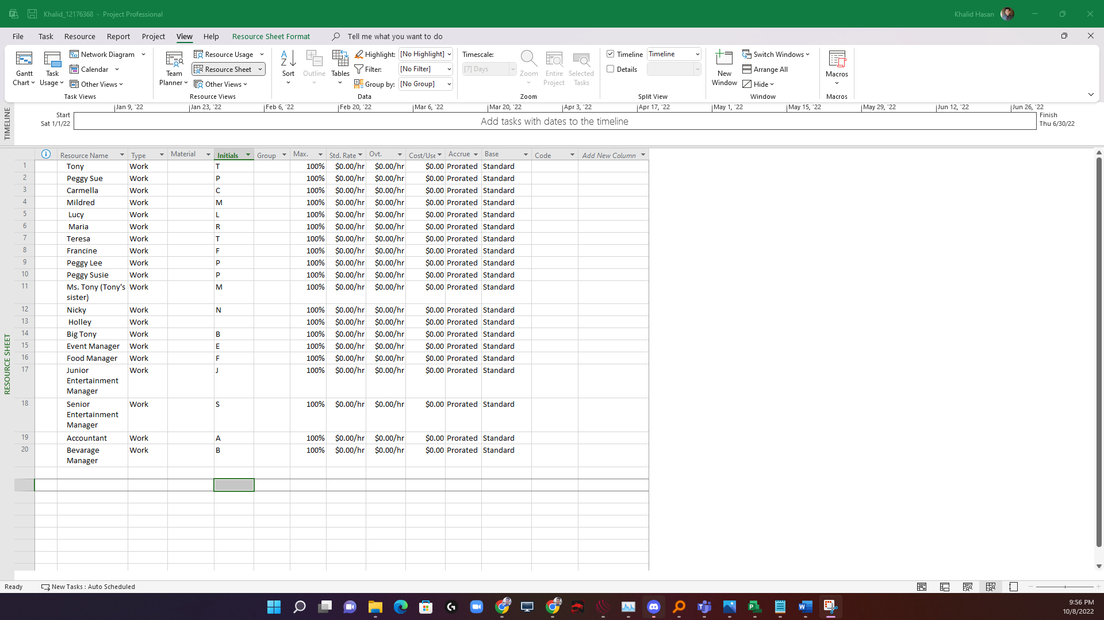

Pic 7: List of the persons who are involved with the Wedding Project.

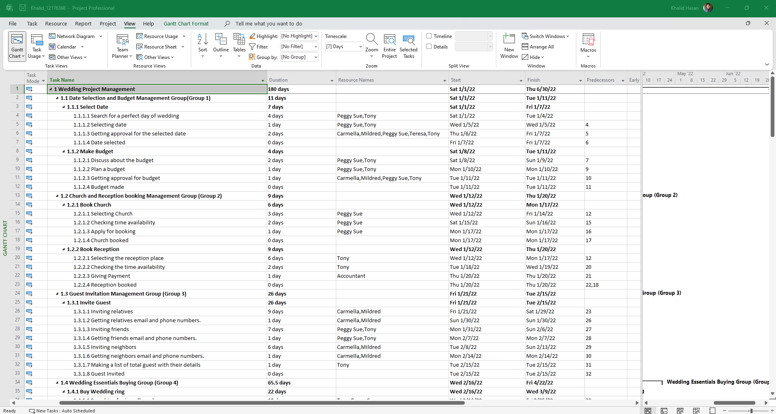

Pic 8: Estimated duration for each activity for the Wedding Project and the responsible person for each task.



Pic 9: WBS structure for the Wedding Project.

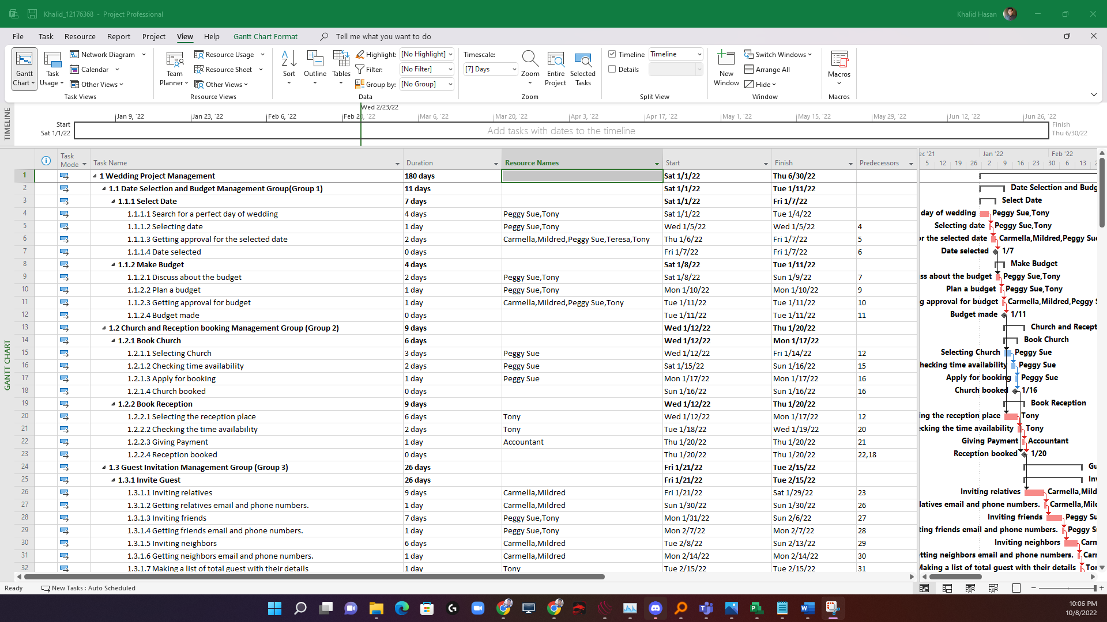

Pic 10: Estimated duration for each activity for the Wedding Project and the responsible person for each task.

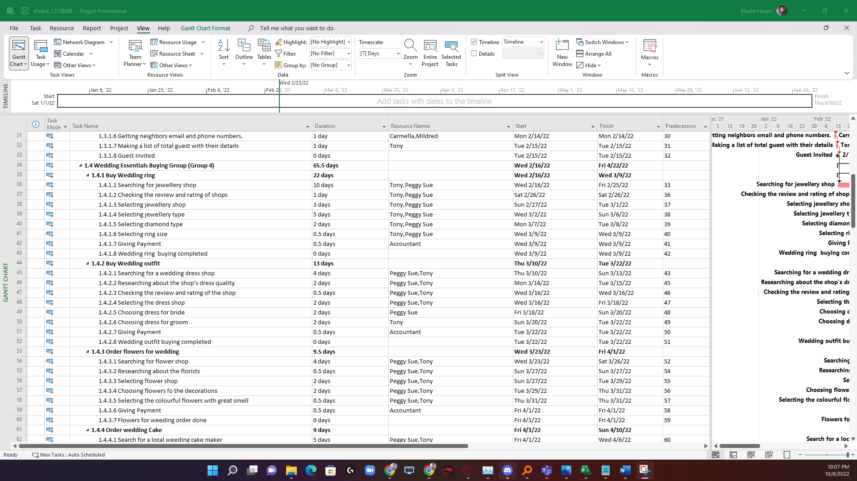

Pic 11: Estimated duration for each activity for the Wedding Project and the responsible person for each task.

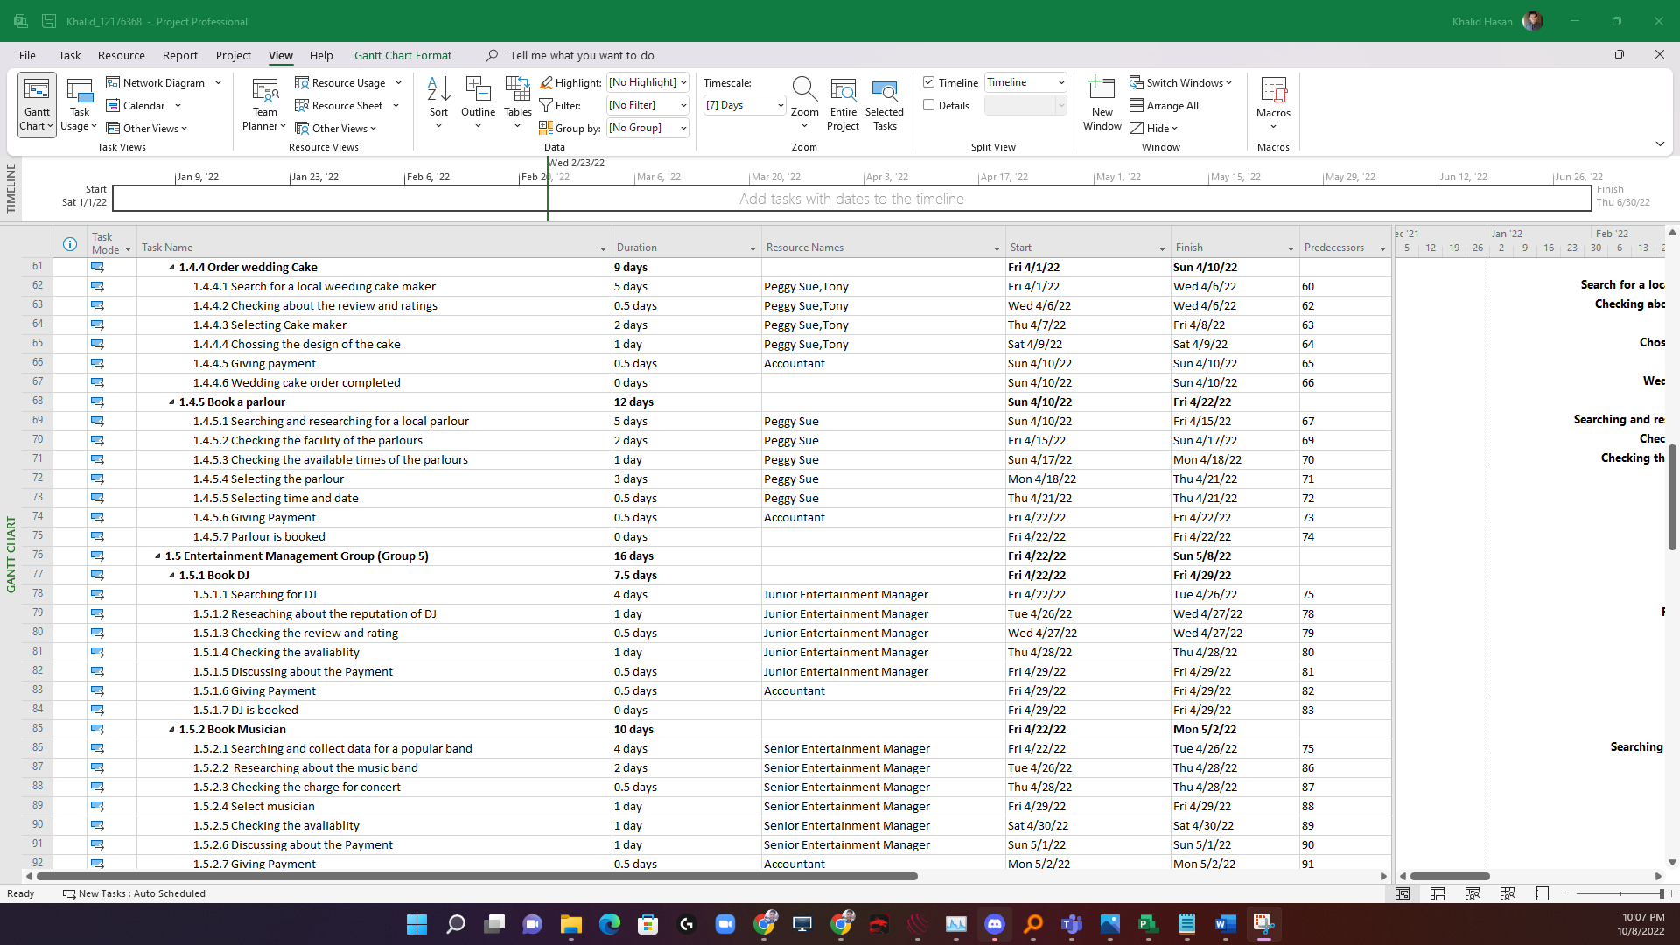

Pic 12: Estimated duration for each activity for the Wedding Project and the responsible person for each task.

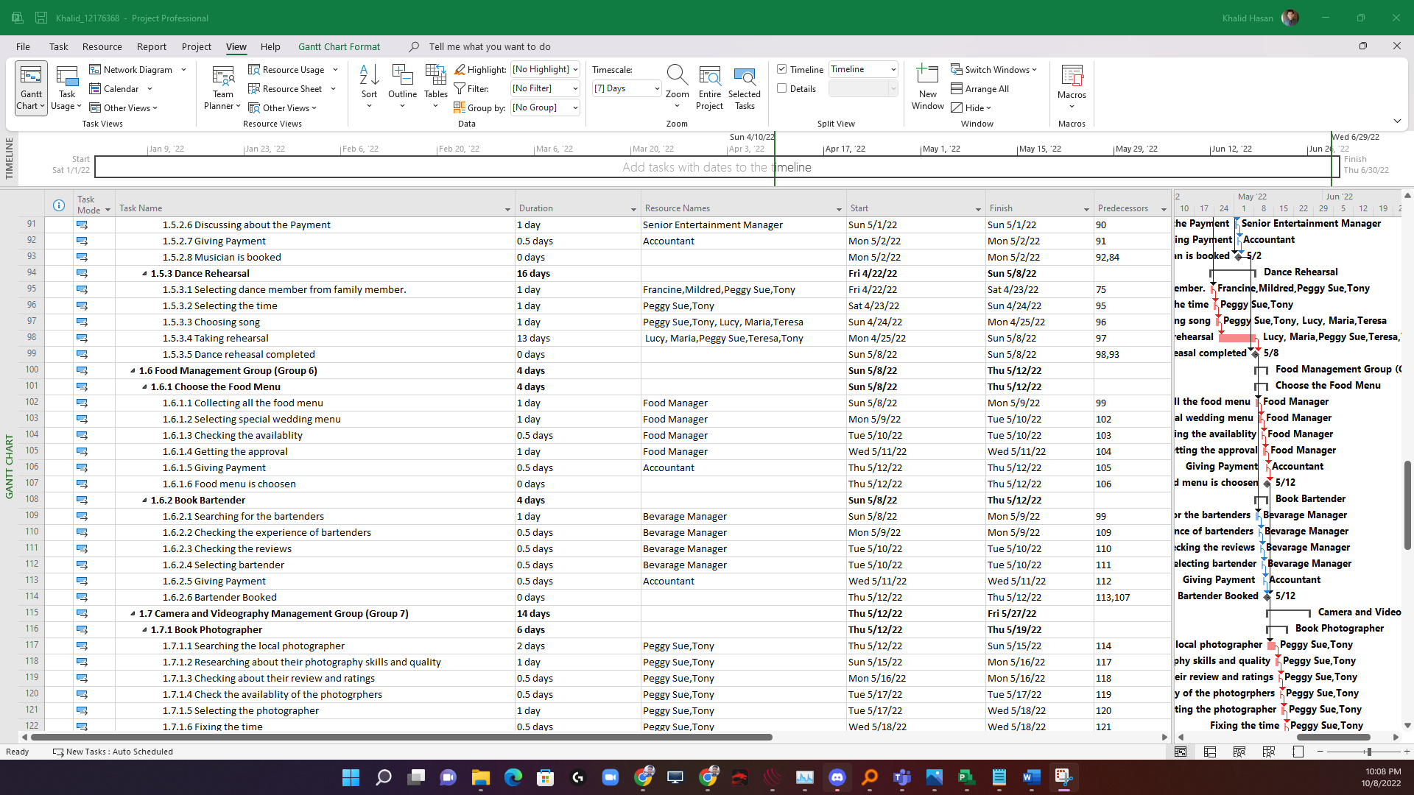

Pic 13: Estimated duration for each activity for the Wedding Project and the responsible person for each task.

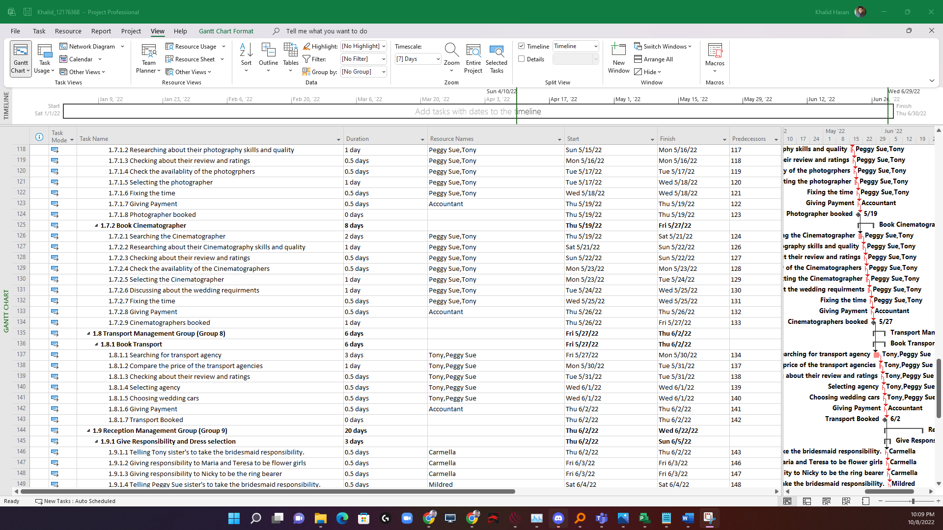

Pic 14: Estimated duration for each activity for the Wedding Project and the responsible person for each task.

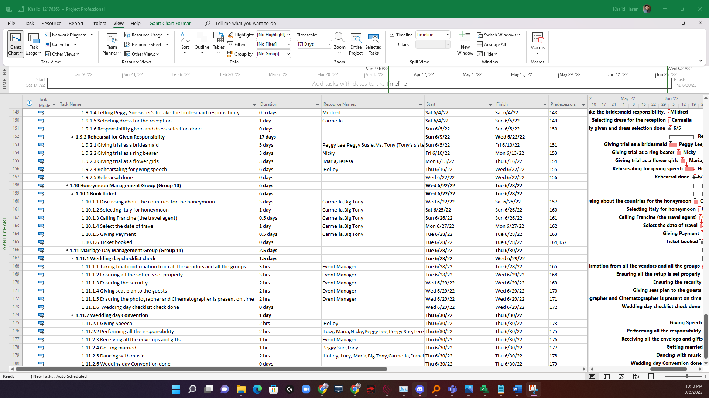

Pic 15: Estimated duration for each activity for the Wedding Project and the responsible person for each task.

A network diagram is an infrastructure of a project and it helps to visualize the tasks that needed to be completed on time with the sequence and dependent relationships of all the activities. The network diagram also shows which is the critical path and the link between each task. Every project has tasks and a project is the combination of tasks, duration, start time, end time, Resource names, predecessors, and critical path. Critical path means a task that must be done on time, otherwise, the full project will cross the deadline. That means the project will not complete on time. Not every task is critical in a project because not every task is similarly equally important. A critical path is important because it identifies the task which is must be needed for the project and this also shows that the tasks must be done on a fixed time.

In the Wedding Project, there are summary tasks, tasks, critical paths, and predecessors. In the network diagram, we can see there are 2 colors combination being used. The red color is used for the critical path and the blue color is used for the normal task.

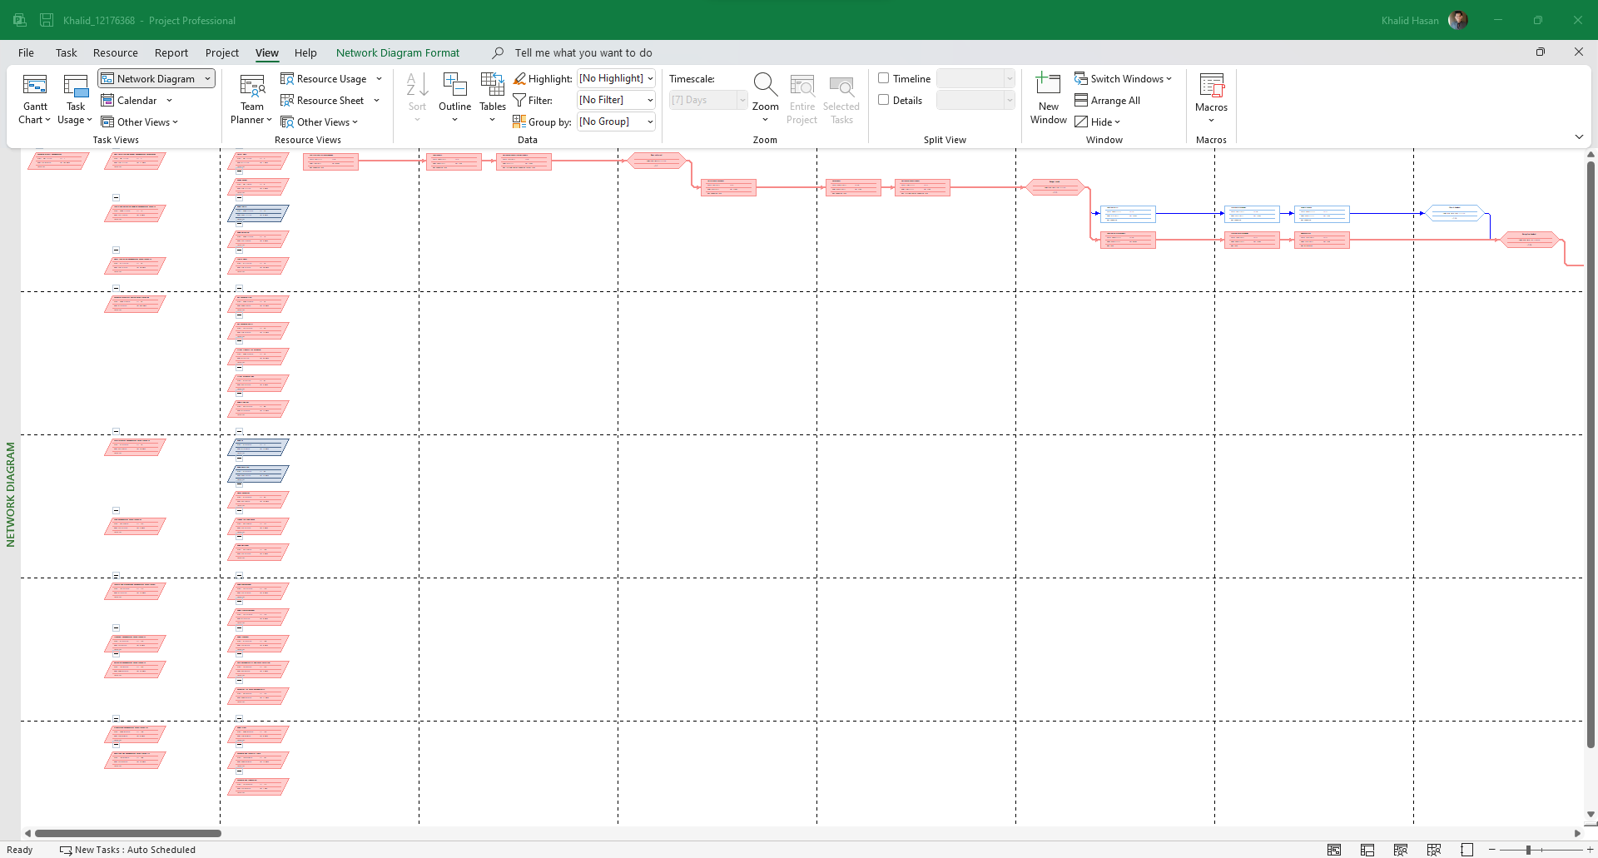

Pic 16: Network diagram of the *weeding project*.

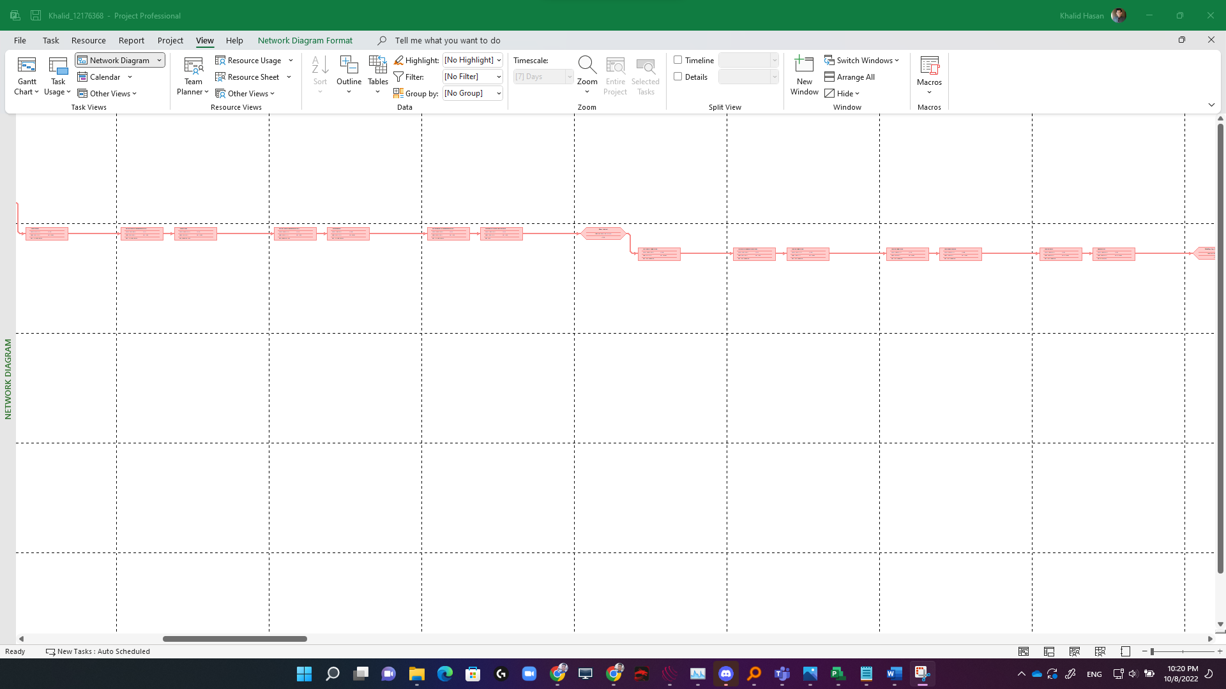

Pic 17: Network diagram of the *weeding project*.

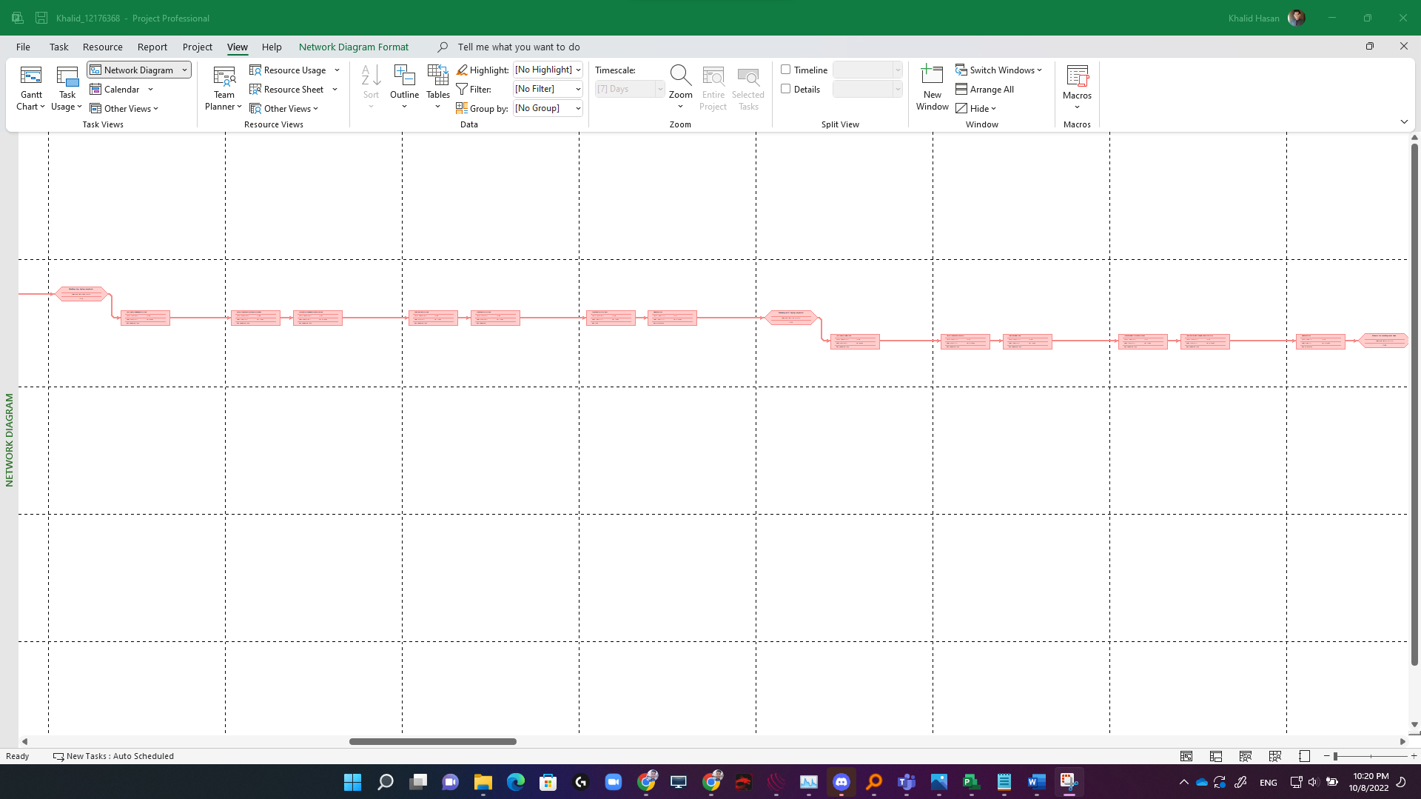

Pic 18: Network diagram of the *weeding project*.

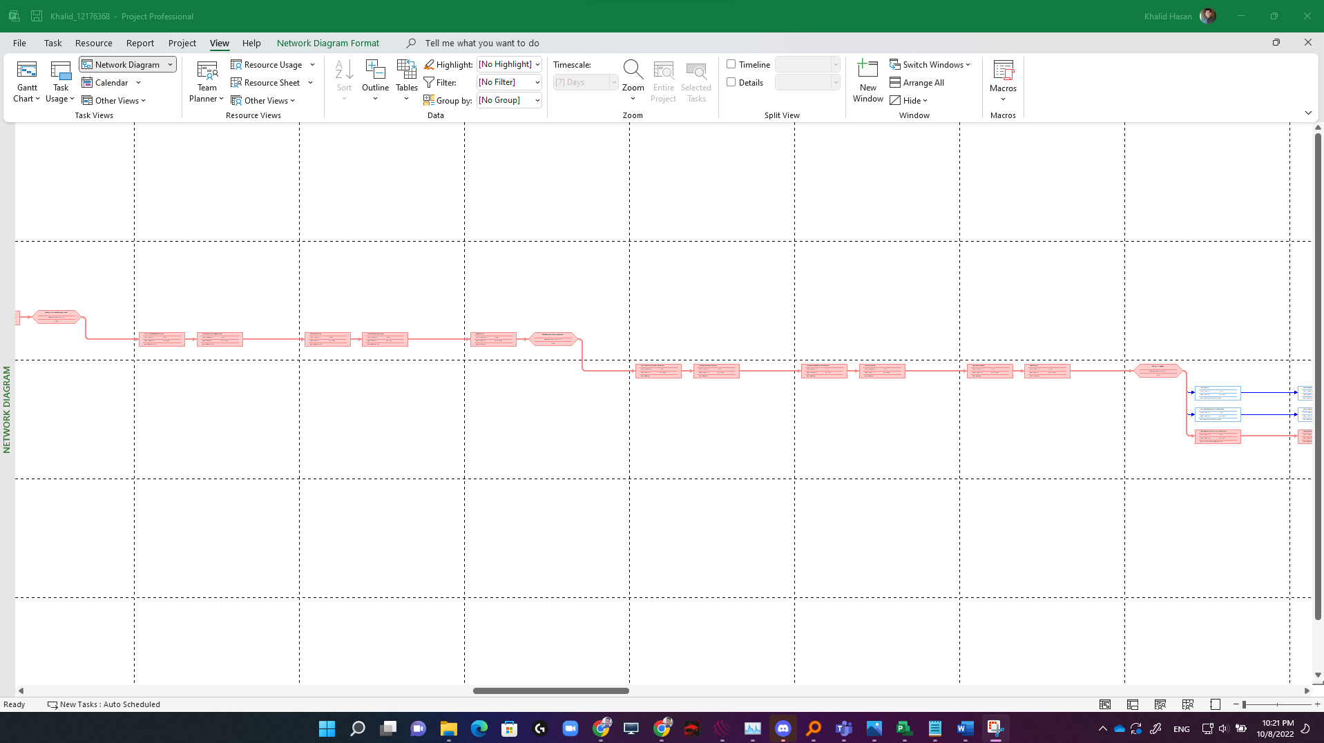

Pic 19: Network diagram of the *weeding project*.

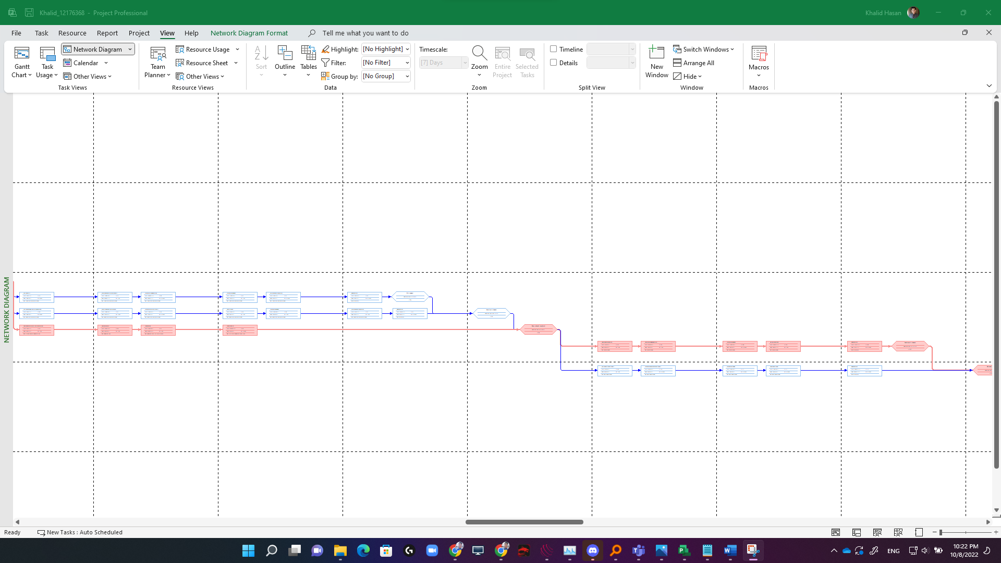

Pic 20: Network diagram of the *weeding project*.

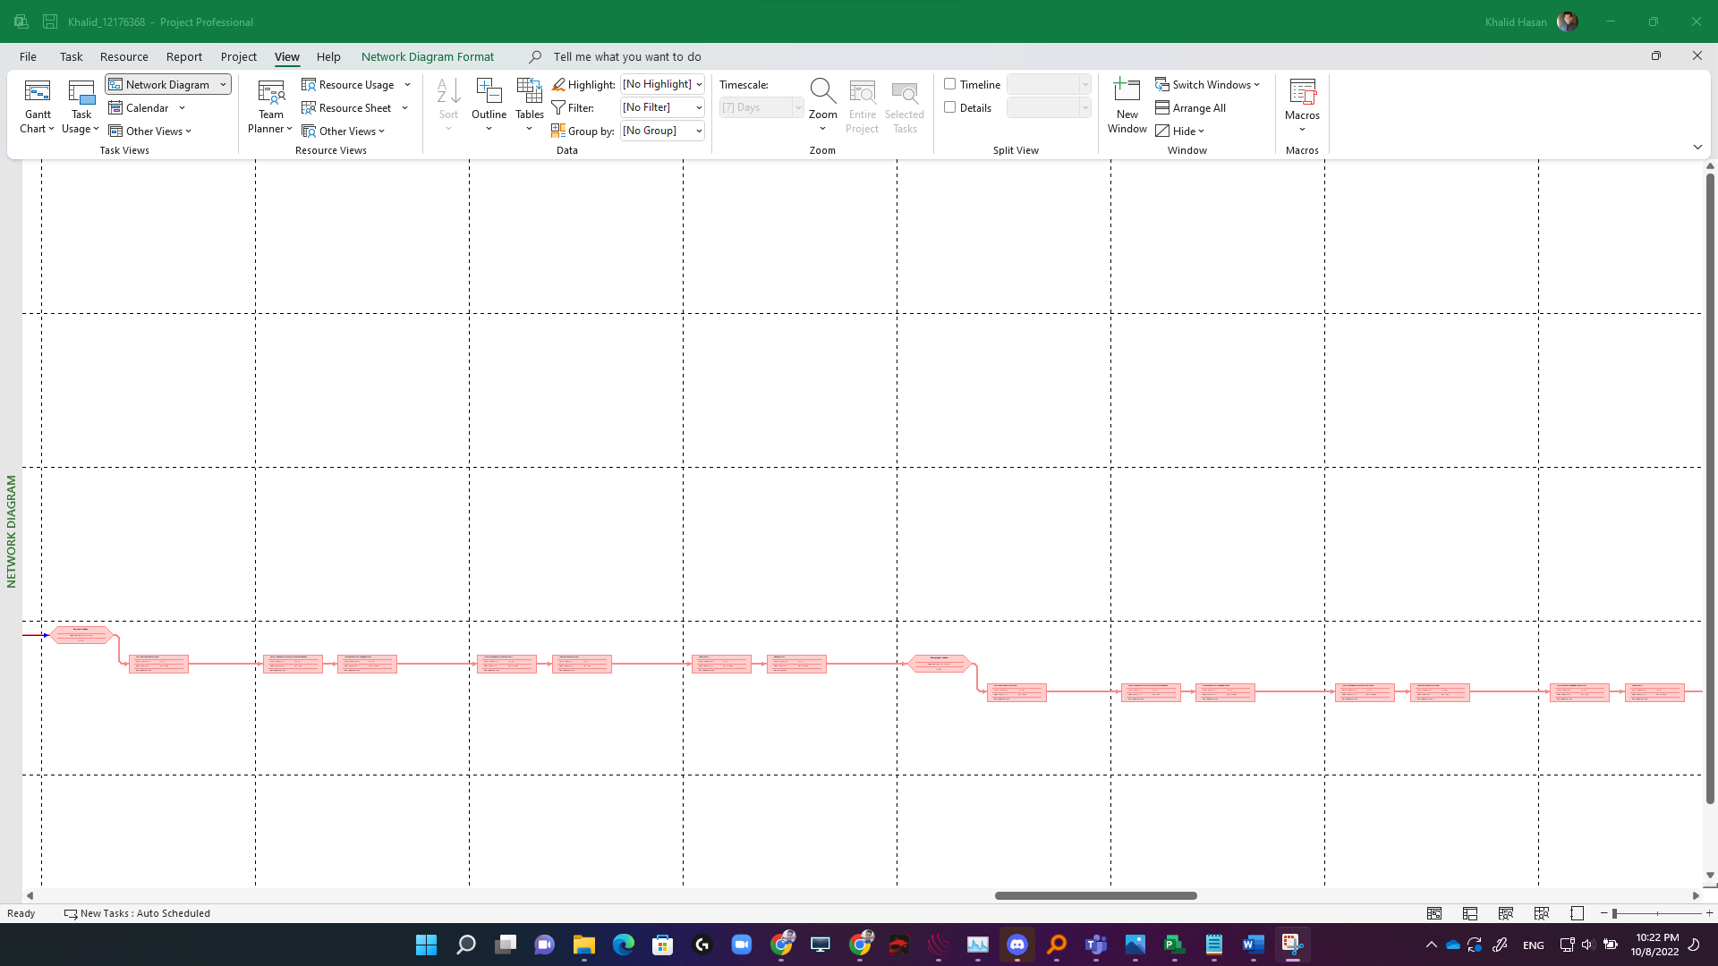

Pic 21: Network diagram of the *weeding project*.

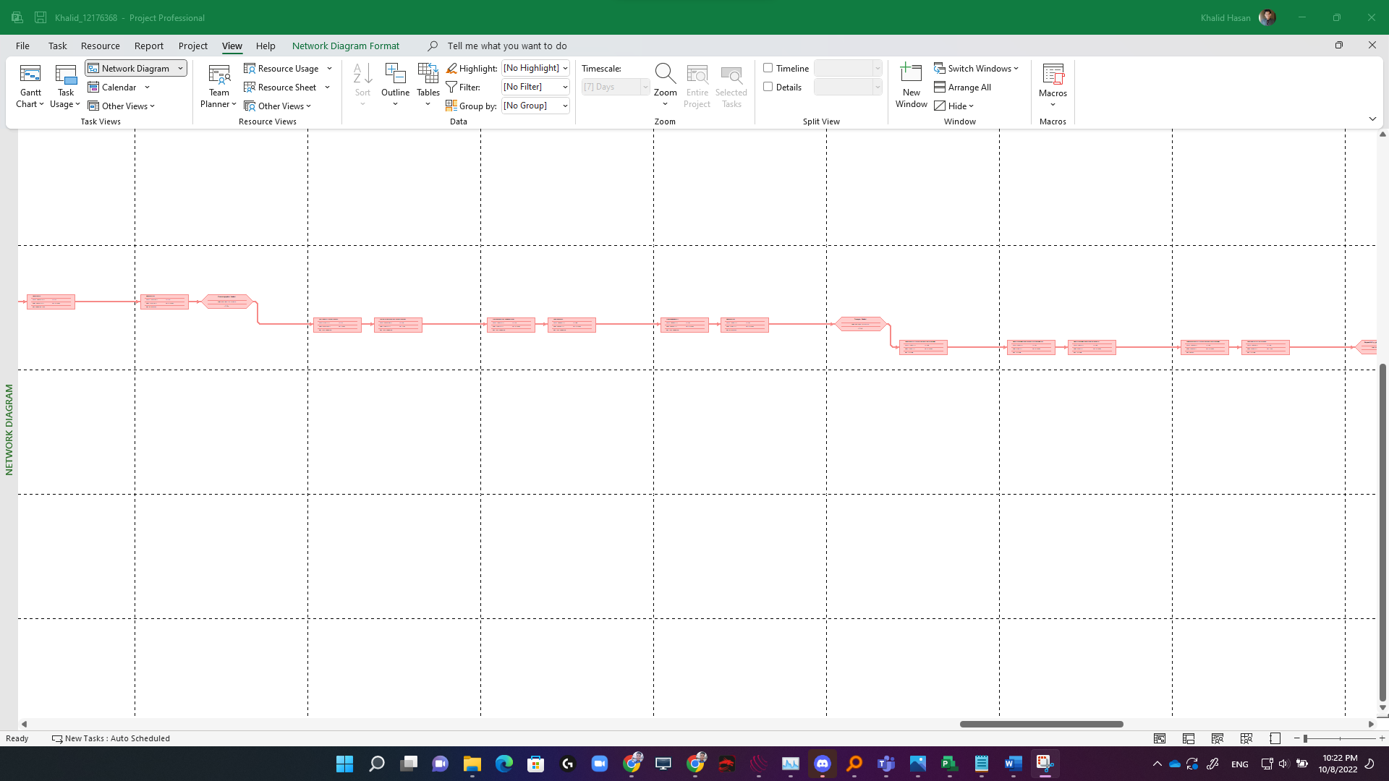

Pic 22: Network diagram of the *weeding project*.

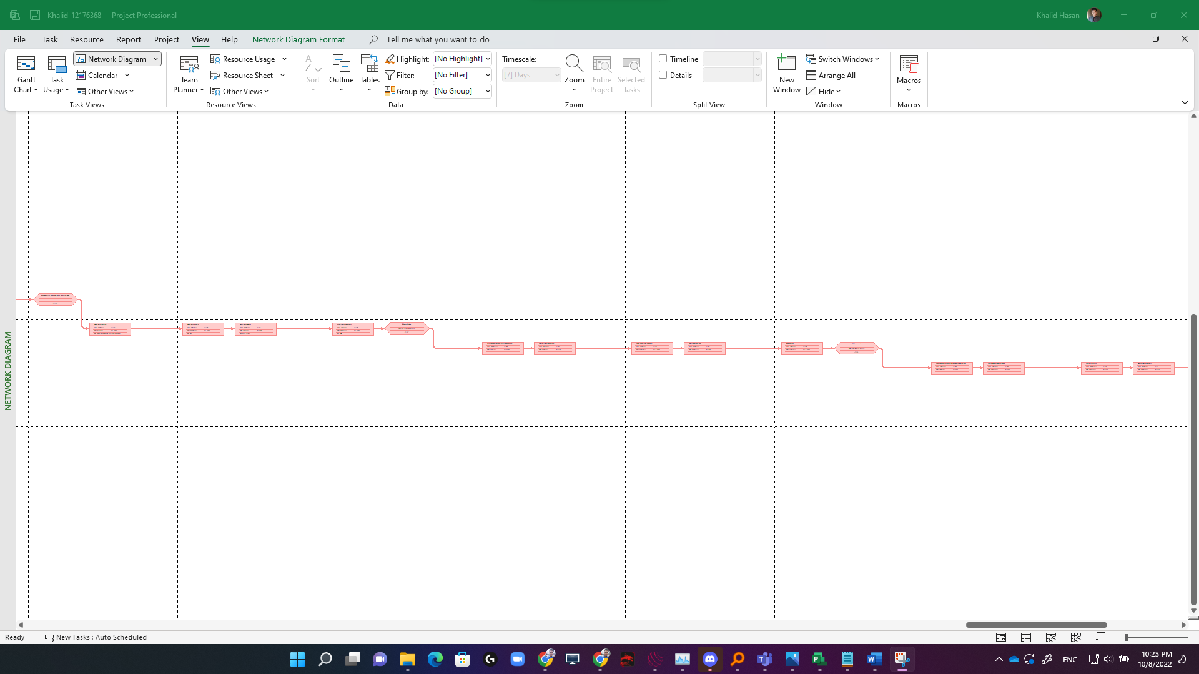

Pic 23: Network diagram of the *weeding project*.

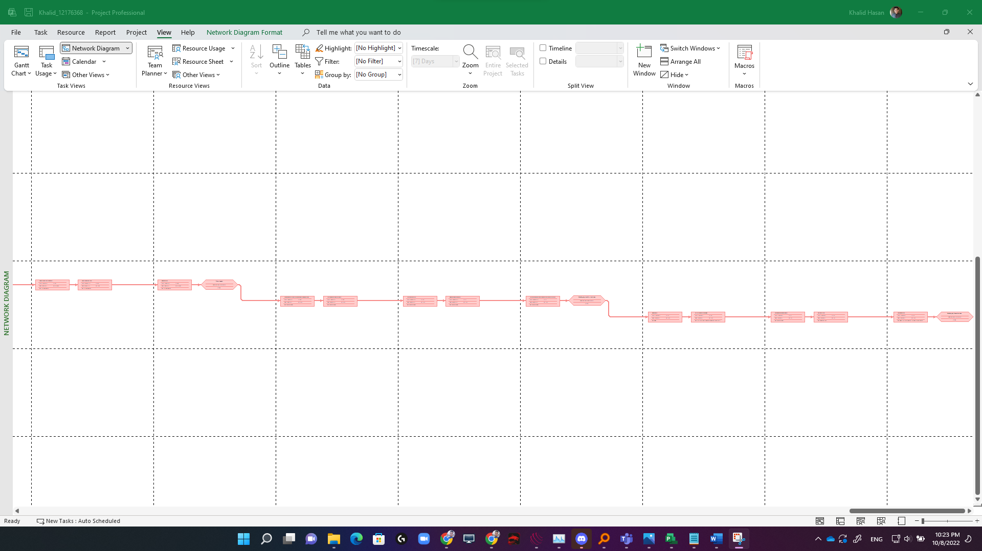

Pic 24: Network diagram of the *weeding project*.

The project is about Tony and Peggy Sue's wedding. In this project, there is a total duration of 180 days. The start date of the project is 1 January 2022 and the project closing date is 30 June 2022. In this project, there is only one break day for refreshments and the date of the break is 13 May 2022. This a mid-wedding break for every person. There are groups for every task. The groups are made to control and complete the task efficiently. There is a total of 11 groups in the full project. In each group, there are summary tasks, tasks, and milestone and every summary task have a milestone so that project-related people can complete it easily. The milestone makes sure that all the tasks are completed. There is a total of 180 tasks in this project and a total of 20 people including outsiders are involved in this project directly. There is an Event Manager to manage the event and take care of the event, food manager is to check the quality of the food and selects the menu for the wedding days, and gives the order of food. On the other hand, there is a beverage manager who will book a perfect bartender for the wedding day. In addition, there is a total of 2 managers for the entertainment who will manage the entertainment sector. There is an accountant who will spend money as per the budget and pay all the bills for the wedding.

This project also has an Early Start and Early Finish column. Early Start means the earlier day a project can start and early finish mean how early a project can be finished. If we look at the screenshot then, we can see there are early start and early finish times for each task.

Besides, the project contains Late start and Late finish columns as well. A late start means the latest day, a project can be started and a late finish means the latest day to finish the project.

In addition, the Wedding project also contains total slack. Slack means an amount of time, a task can be delayed without giving any impact on the project deadline. In my project, there is no negative slack the project started on 1 January and the closing time is 30 June 2022. The total duration is 180 days and there is only one day break on 13 May. So, there is no negative slack that will affect my deadline. The project successfully meets all the requirements of the project without any further delay and negative slack.

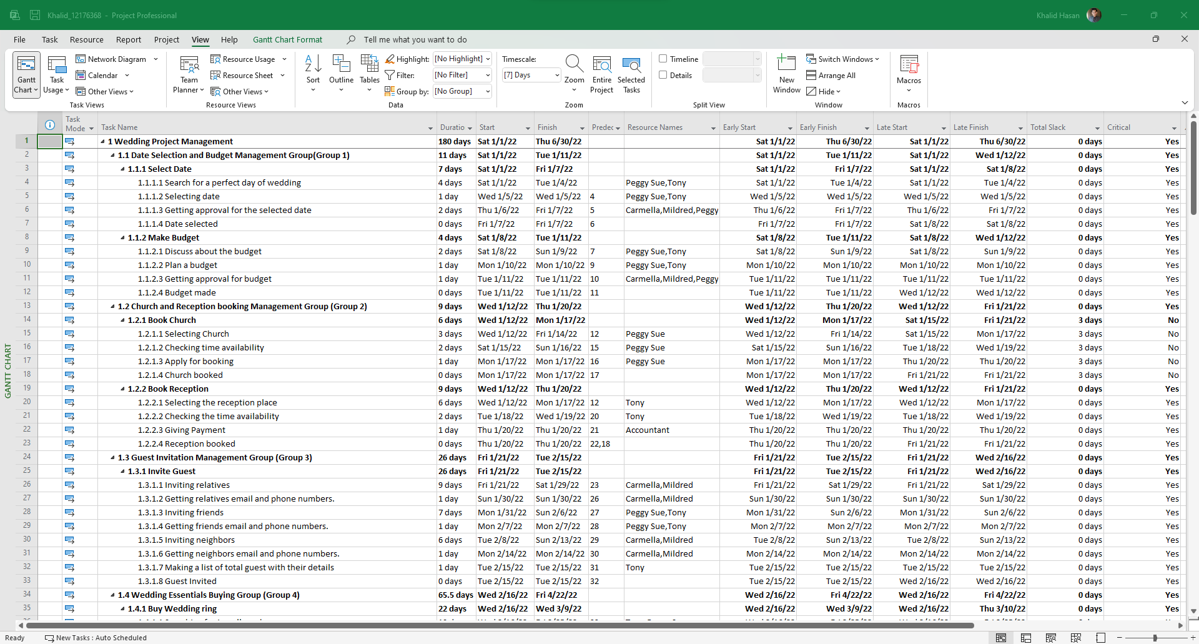

Pic 26: Task Name, Duration, start time, Finish Time, Predecessor, Resource Name, Early Start, Early Finish, Total Slack, and Critical section for the Wedding Project.

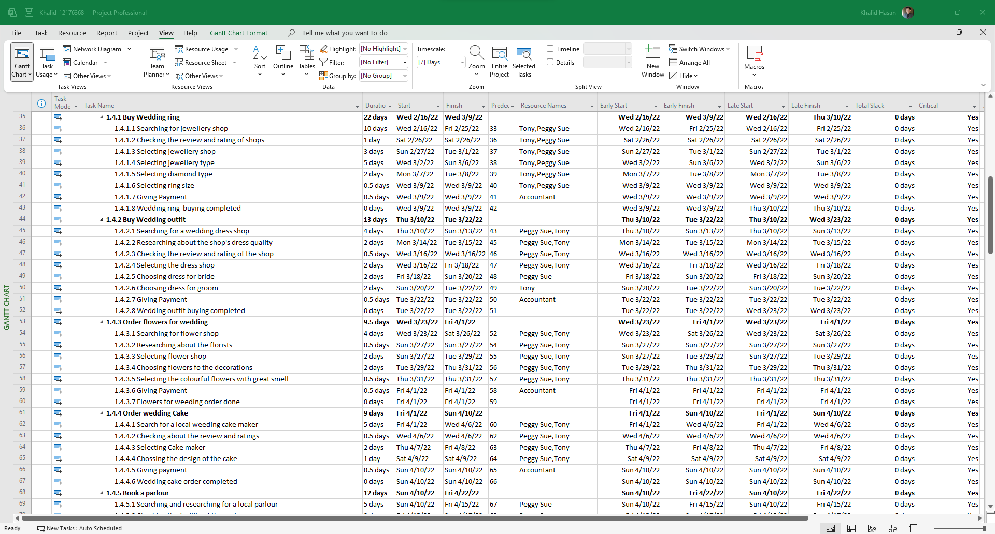

Pic 27: Task Name, Duration, start time, Finish Time, Predecessor, Resource Name, Early Start, Early Finish, Total Slack, and Critical section for the Wedding Project.

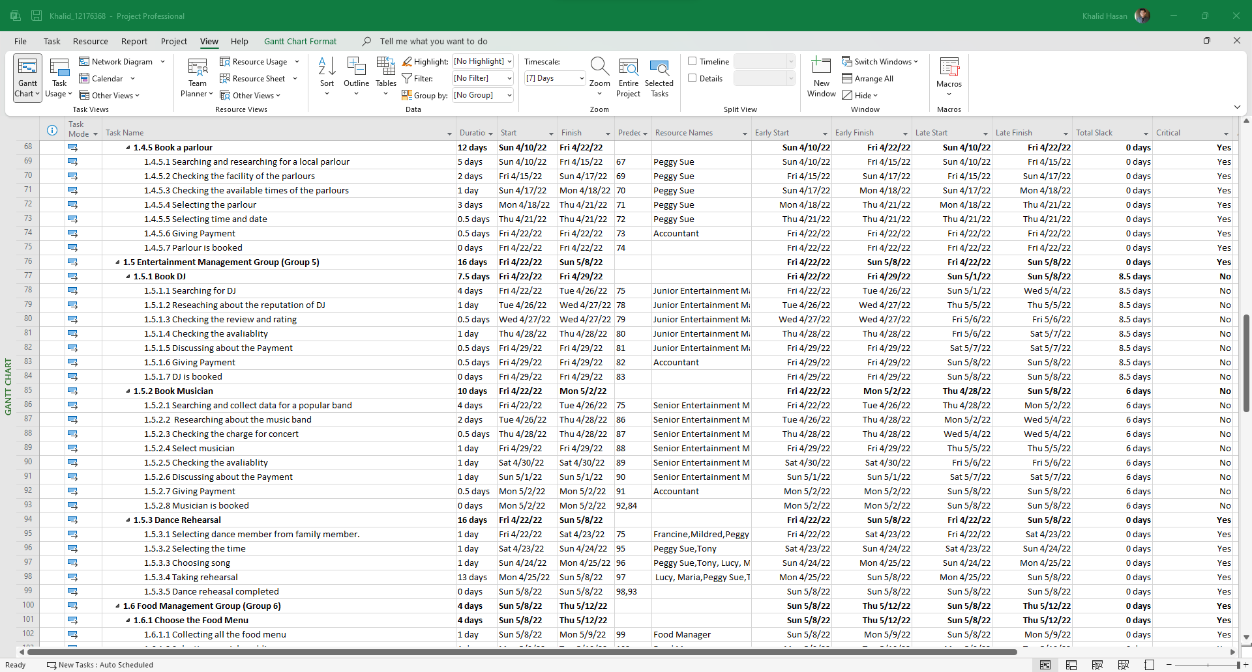

Pic 28: Task Name, Duration, start time, Finish Time, Predecessor, Resource Name, Early Start, Early Finish, Total Slack, and Critical section for the Wedding Project.

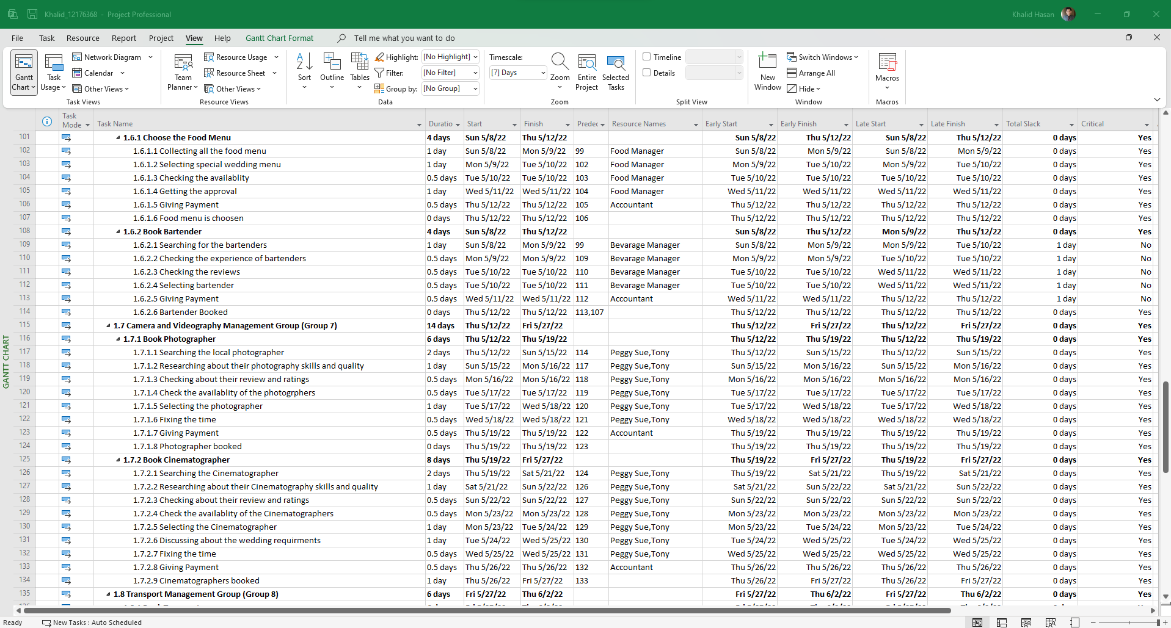

Pic 29: Task Name, Duration, start time, Finish Time, Predecessor, Resource Name, Early Start, Early Finish, Total Slack, and Critical section for the Wedding Project.

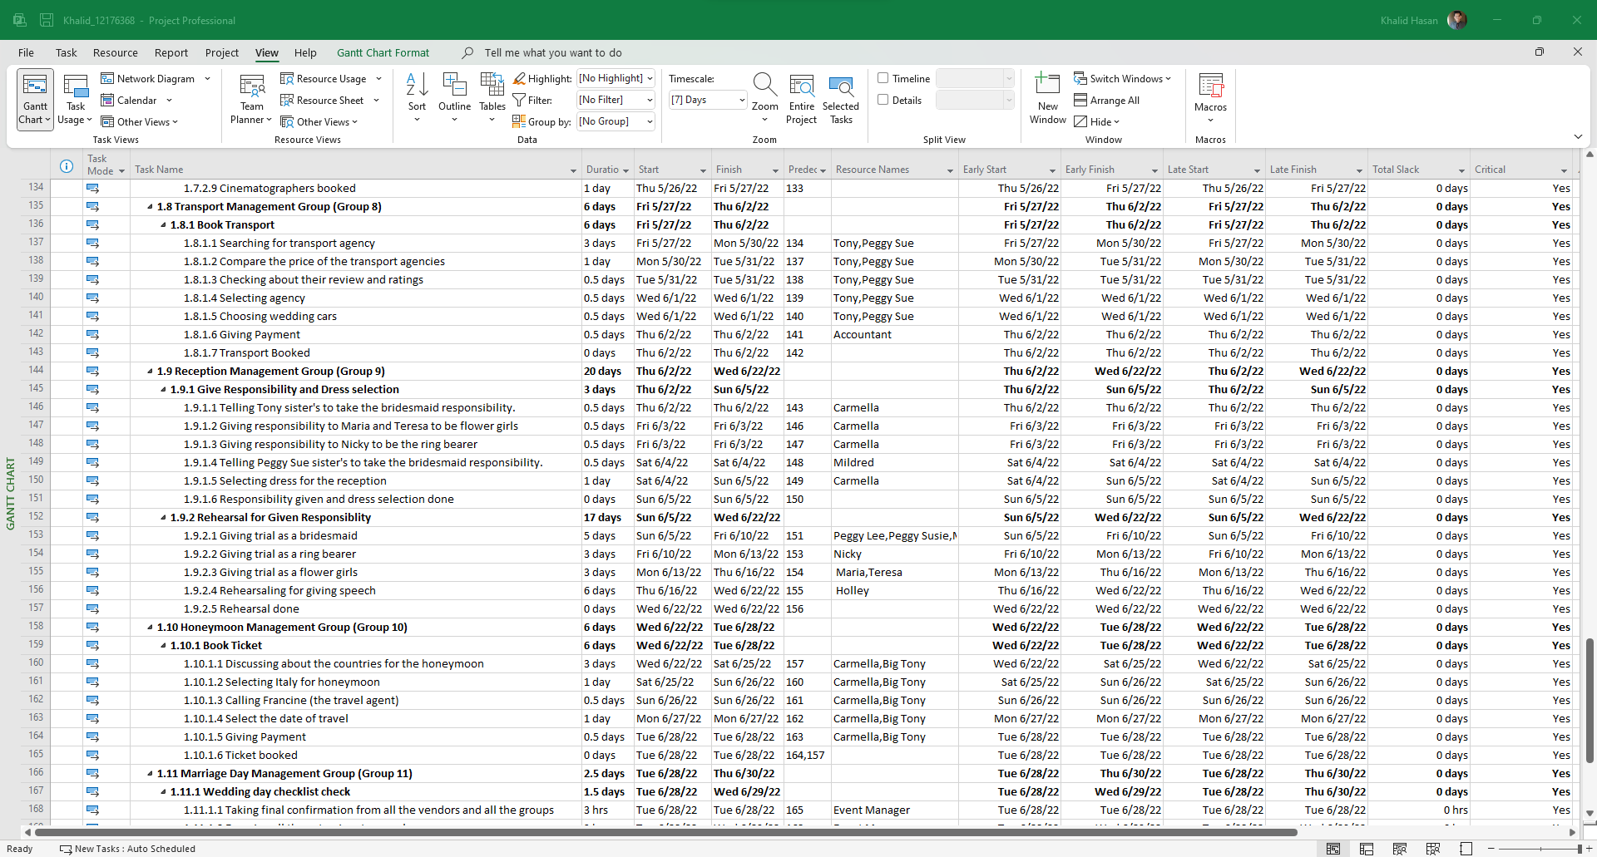

Pic 30: Task Name, Duration, start time, Finish Time, Predecessor, Resource Name, Early Start, Early Finish, Total Slack, and Critical section for the Wedding Project.

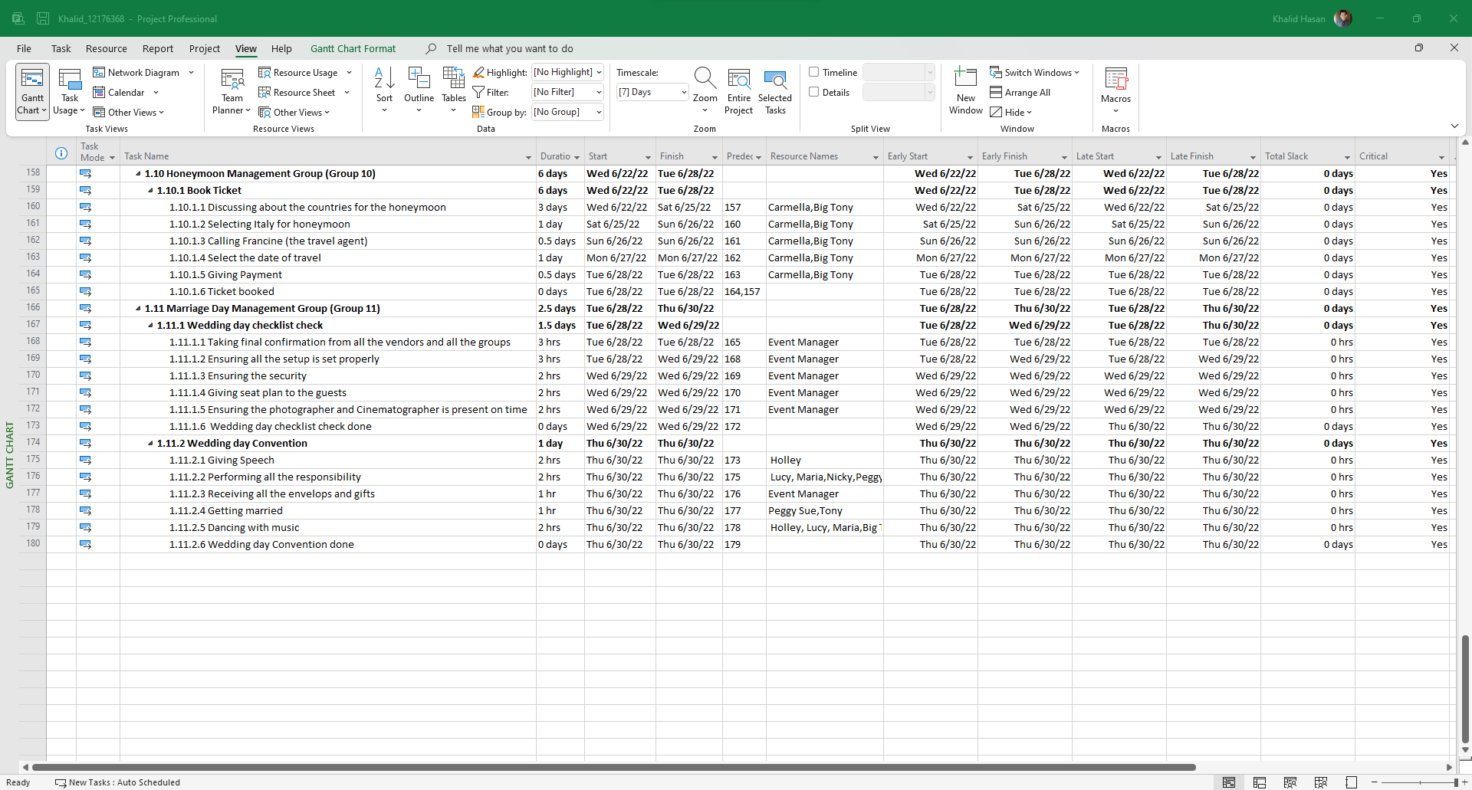

Pic 31: Task Name, Duration, start time, Finish Time, Predecessor, Resource Name, Early Start, Early Finish, Total Slack, and Critical section for the Wedding Project.

The critical path indicates that a task must be completed on time, otherwise, the full project will cross the deadline and that can also be a failed project if the project can’t be delivered on the deadline. Not every task is critical in a project because not every task is similarly equally important as a critical path. A critical path is important because it identifies the task which is must be needed for the project and this also shows that the tasks are important and must be done on a fixed time.

Identifying the activities that make up the critical path of the wedding project below. Those tasks are important to complete because if it remains pending then the full project deadline will not meet anymore and potential delay can happen.

|  |
| --- |
| 1. **Date Selection and Budget Management Group(Group 1)** |
| 1. **Select Date** |
| 1. Search for a perfect day of wedding |
| 1. Selecting date |
| 1. Getting approval for the selected date |
| 1. Date selected |
| 1. **Make Budget** |
| 1. Discuss about the budget |
| 1. Plan a budget |
| 1. Getting approval for budget |
| 1. Budget made |
| 1. Book Reception |
| 1. Selecting the reception place |
| 1. Checking the time availability |
| 1. Giving Payment |
| 1. Reception booked |
| 1. Guest Invitation Management Group (Group 3) |
| 1. Invite Guest |
| 1. Inviting relatives |
| 1. Getting relatives email and phone numbers. |
| 1. Inviting friends |
| 1. Getting friends email and phone numbers. |
| 1. Inviting neighbors |
| 1. Getting neighbors email and phone numbers. |
| 1. Making a list of total guest with their details |
| 1. Guest Invited |
| 1. Wedding Essentials Buying Group (Group 4) |
| 1. Buy Wedding ring |
| 1. Searching for jewellery shop |
| 1. Checking the review and rating of shops |
| 1. Selecting jewellery shop |
| 1. Selecting jewellery type |
| 1. Selecting diamond type |
| 1. Selecting ring size |
| 1. Giving Payment |
| 1. Wedding ring buying completed |
| 1. Buy Wedding outfit |
| 1. Searching for a wedding dress shop |
| 1. Researching about the shop's dress quality |
| 1. Checking the review and rating of the shop |
| 1. Selecting the dress shop |
| 1. Choosing dress for bride |
| 1. Choosing dress for groom |
| 1. Giving Payment |
| 1. Wedding outfit buying completed |
| 1. Order flowers for wedding |
| 1. Searching for flower shop |
| 1. Researching about the florists |
| 1. Selecting flower shop |
| 1. Choosing flowers fo the decorations |
| 1. Selecting the colourful flowers with great smell |
| 1. Giving Payment |
| 1. Flowers for weeding order done |
| 1. Order wedding Cake |
| 1. Search for a local weeding cake maker |
| 1. Checking about the review and ratings |
| 1. Selecting Cake maker |
| 1. Chossing the design of the cake |
| 1. Giving payment |
| 1. Wedding cake order completed |
| 1. Book a parlour |
| 1. Searching and researching for a local parlour |
| 1. Checking the facility of the parlours |
| 1. Checking the available times of the parlours |
| 1. Selecting the parlour |
| 1. Selecting time and date |
| 1. Giving Payment |
| 1. Parlour is booked |
| 1. Dance Rehearsal |
| 1. Selecting dance member from family member. |
| 1. Selecting the time |
| 1. Choosing song |
| 1. Taking rehearsal |
| 1. Dance reheasal completed |
| 1. Food Management Group (Group 6) |
| 1. Choose the Food Menu |
| 1. Collecting all the food menu |
| 1. Selecting special wedding menu |
| 1. Checking the availablity |
| 1. Getting the approval |
| 1. Giving Payment |
| 1. Food menu is choosen |
| 1. Book Bartender |
| 1. Searching for the bartenders |
| 1. Checking the experience of bartenders |
| 1. Checking the reviews |
| 1. Selecting bartender |
| 1. Giving Payment |
| 1. Bartender Booked |
| 1. Bartender Booked |
| 1. Camera and Videography Management Group (Group 7) |
| 1. Book Photographer |
| 1. Searching the local photographer |
| 1. Researching about their photography skills and quality |
| 1. Checking about their review and ratings |
| 1. Check the availablity of the photogrphers |
| 1. Selecting the photographer |
| 1. Fixing the time |
| 1. Giving Payment |
| 1. Photographer booked |
| 1. Book Cinematographer |
| 1. Searching the Cinematographer |
| 1. Researching about their Cinematography skills and quality |
| 1. Checking about their review and ratings |
| 1. Check the availablity of the Cinematographers |
| 1. Selecting the Cinematographer |
| 1. Discussing about the wedding requirments |
| 1. Fixing the time |
| 1. Giving Payment |
| 1. Cinematographers booked |
| 1. Transport Management Group (Group 8) |
| 1. Book Transport |
| 1. Searching for transport agency |
| 1. Compare the price of the transport agencies |
| 1. Checking about their review and ratings |
| 1. Selecting agency |
| 1. Choosing wedding cars |
| 1. Giving Payment |
| 1. Transport Booked |
| 1. Reception Management Group (Group 9) |
| 1. Give Responsibility and Dress selection |
| 1. Telling Tony sister's to take the bridesmaid responsibility. |
| 1. Giving responsibility to Maria and Teresa to be flower girls |
| 1. Giving responsibility to Nicky to be the ring bearer |
| 1. Telling Peggy Sue sister's to take the bridesmaid responsibility. |
| 1. Selecting dress for the reception |
| 1. Responsibility given and dress selection done |
| 1. Rehearsal for Given Responsiblity |
| 1. Giving trial as a bridesmaid |
| 1. Giving trial as a ring bearer |
| 1. Giving trial as a flower girls |
| 1. Rehearsaling for giving speech |
| 1. Rehearsal done |
| 1. Honeymoon Management Group (Group 10) |
| 1. Book Ticket |
| 1. Discussing about the countries for the honeymoon |
| 1. Selecting Italy for honeymoon |
| 1. Calling Francine (the travel agent) |
| 1. Select the date of travel |
| 1. Giving Payment |
| 1. Ticket booked |
| 1. Marriage Day Management Group (Group 11) |
| 1. Wedding day checklist check |
| 1. Taking final confirmation from all the vendors and all the groups |
| 1. Ensuring all the setup is set properly |
| 1. Ensuring the security |
| 1. Giving seat plan to the guests |
| 1. Ensuring the photographer and Cinematographer is present on time |
| 1. Wedding day checklist check done |
| 1. Wedding day Convention |
| 1. Giving Speech |
| 1. Performing all the responsibility |
| 1. Receiving all the envelops and gifts |
| 1. Getting married |
| 1. Dancing with music |
| 1. Wedding day Convention done |

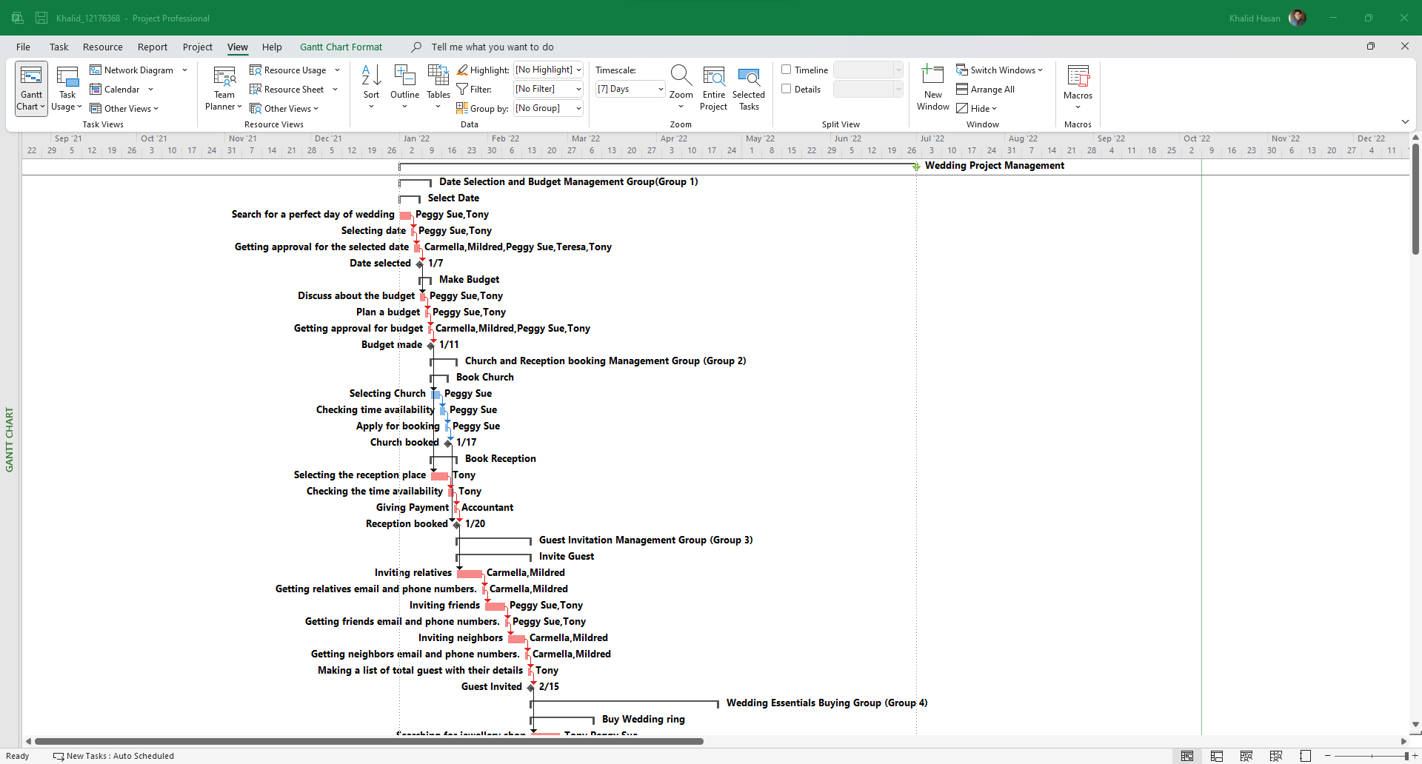

Pic 32: The diagram is showing the critical path of the wedding project.

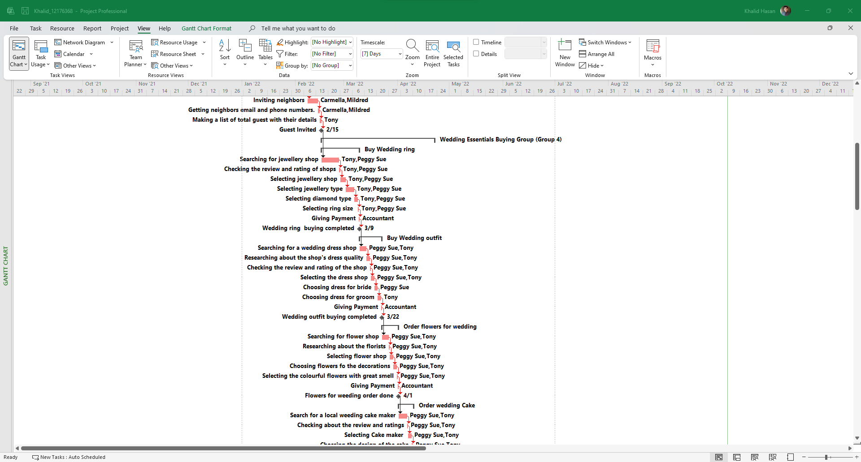

Pic 33: The diagram is showing the critical path of the wedding project.

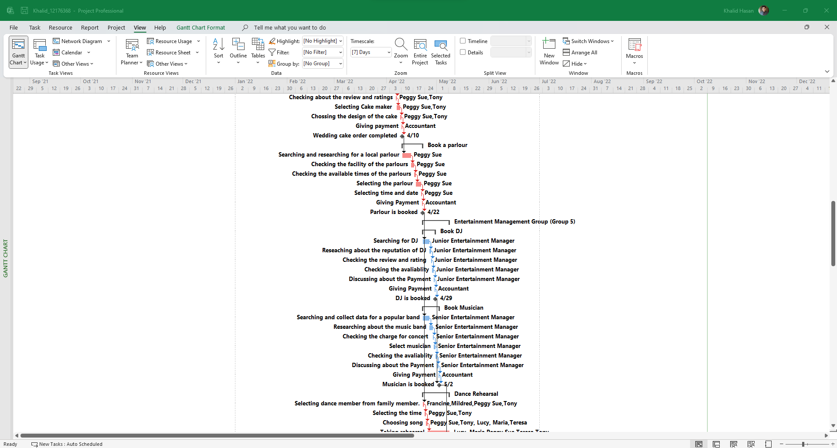

Pic 34: The diagram is showing the critical path of the wedding project.

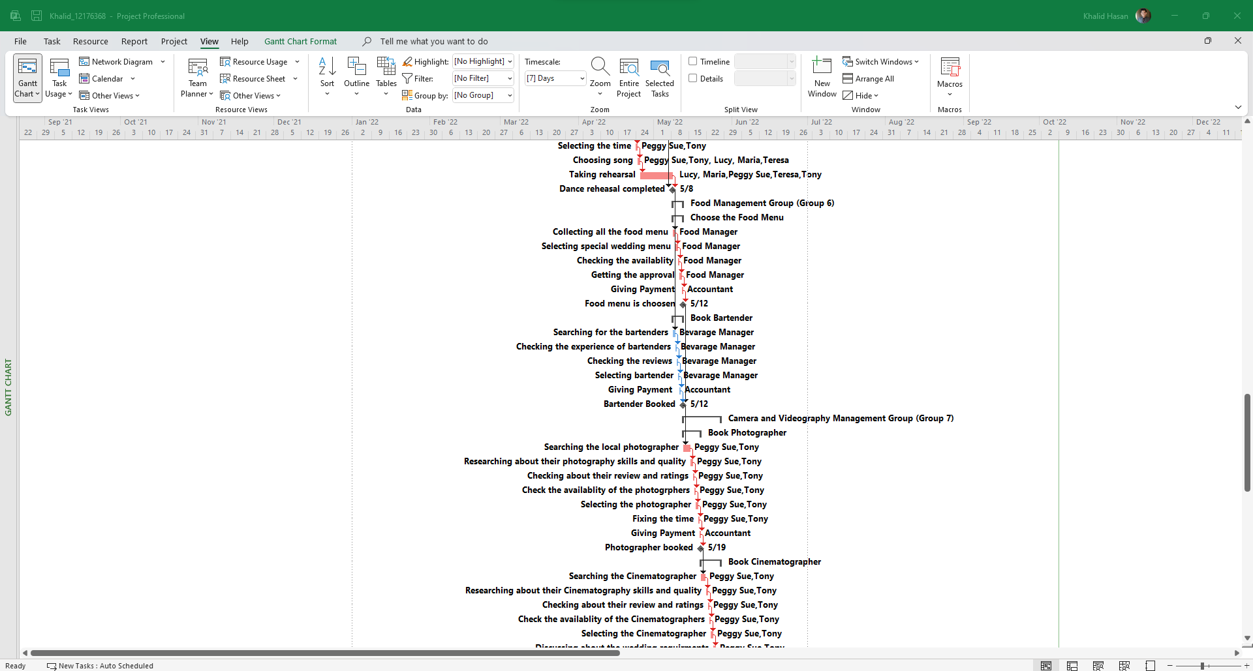

Pic 35: The diagram is showing the critical path of the wedding project.

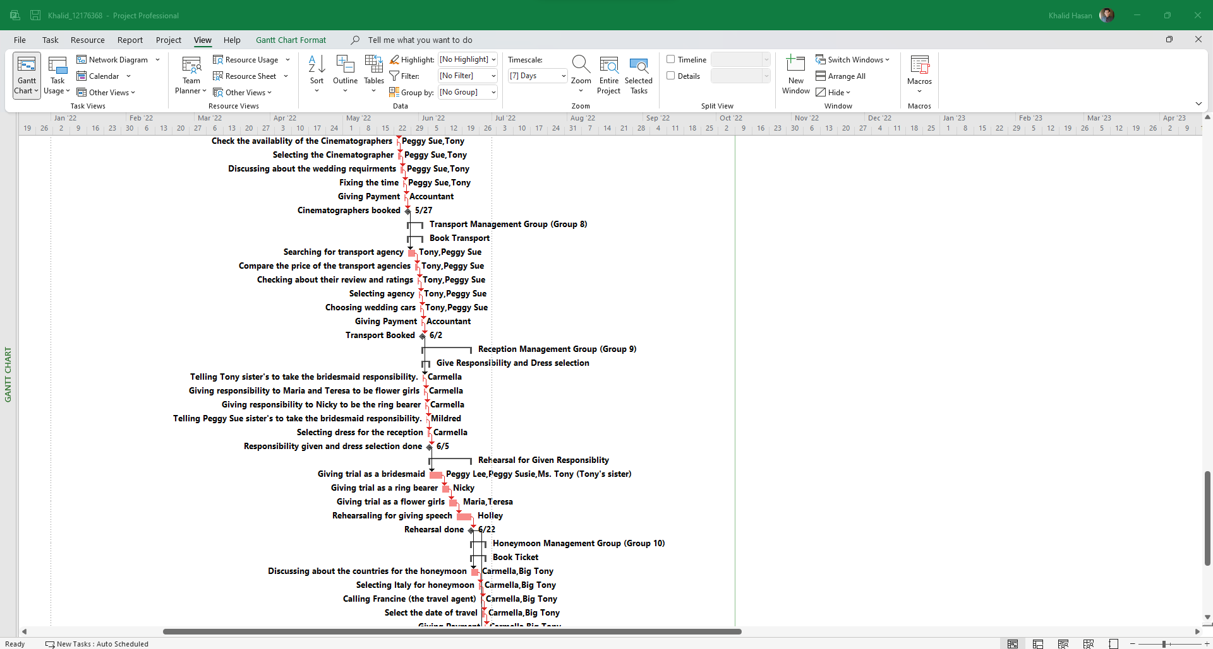

Pic 36: The diagram is showing the critical path of the wedding project.

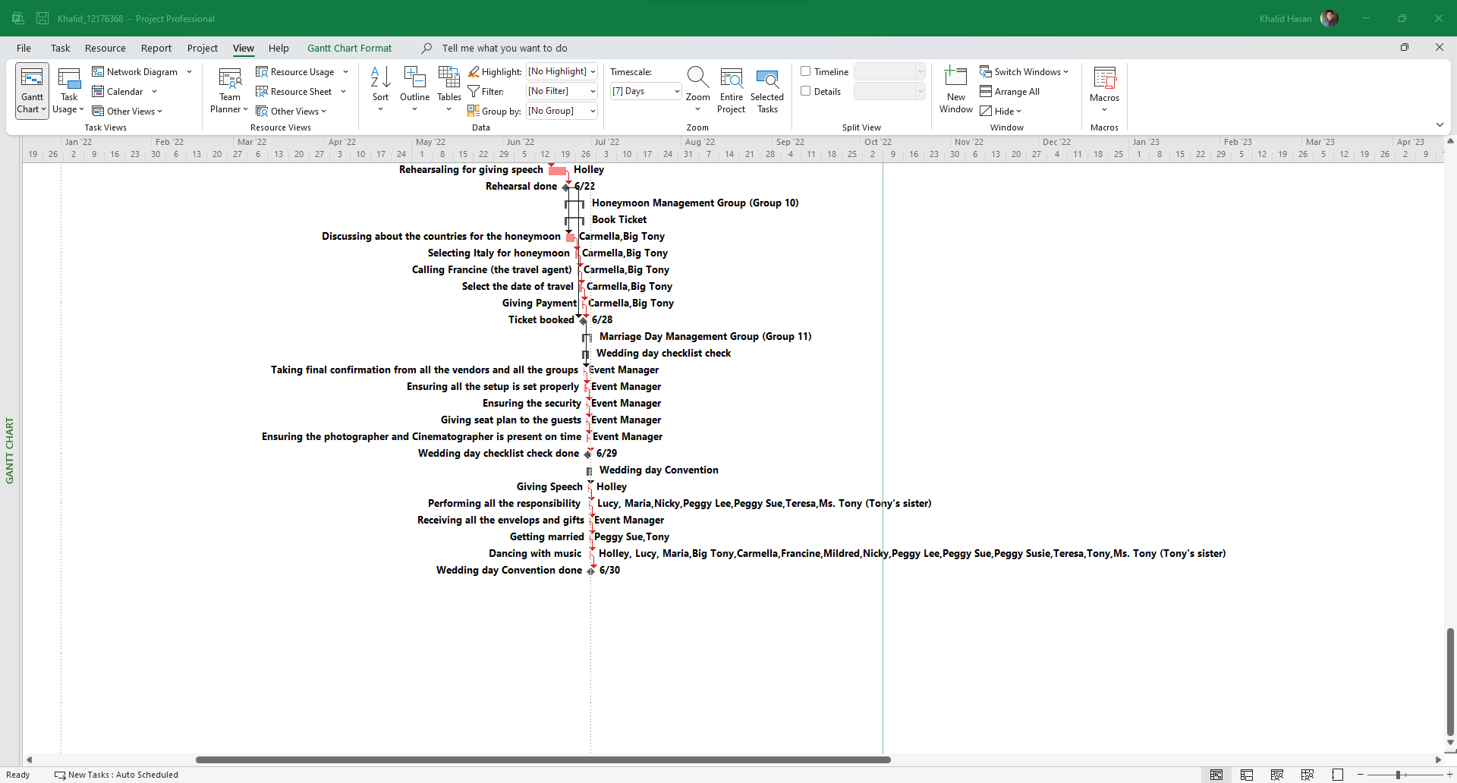

Pic 37: The diagram is showing the critical path of the wedding project.



Pic 38: The diagram is showing the critical path of the wedding project.



Pic 39: The diagram is showing the critical path of the wedding project.



Pic 40: The diagram is showing the critical path of the wedding project.



Pic 41: The diagram is showing the critical path of the wedding project.



Pic 42: The diagram is showing the critical path of the wedding project.



Pic 43: The diagram is showing the critical path of the wedding project.